**Online Job Portal System**

**Project Report**

**By**

**ACKNOWLEDGEMENT**

I would like to thank my Major Professor, XYZ for believing in me, my capabilities and keeping his faith on me that I would be able to finish the project on time. His constant guidance, encouragement and valuable feedback led to the successful completion of this project. I extend my heartfelt thanks to HOD XYZ for serving on my committee and being my academic advisor, guiding me through all the major decisions and above all believing in my abilities. And I cannot finish without thanking my Mother for always believing in me and my abilities, for pushing me a step further whenever I have stumbled. A cheerful thanks to few significant friends without whose constant love, help, support and motivation this task would not have been achieved. Above all, thank you God for all the opportunities that you have given me.

**----------------------**

**Abstract**

The purpose of “Online Job Portal System” is to automate the existing manual system by the help of computerized equipments and full-fledge computer software, fulfilling their requirements, so that their valuable data/information can be stored for a longer period with easy accessing and manipulation of the same. The required software and hardware are easily available and easy to work with.

“Online Job Portal System” is secure, reliable and fast management system. It can assist the user to concentrate on their activities rather to concentrate on the record keeping. Thus it will help organization in better utilization of resources. The organization can maintain computerized records without redundant entries. That means that one need not be distracted by information that is not relevant, while being able to reach the information.

The aim is to automate its existing system by the help of computerized equipments and full-fledge computer software, fulfilling their requirements, so that their valuable data/information can be stored for a longer period with easy accessing and manipulation of the same. Basically the project describes how to manage for good performance and better services for the clients.

**Objective**

Computerized online Job Search System is developed to facilitate the General administration system to manage the various information of the Job Seeker and Employer and the processes involved in a placement company. So, that organization can access accurate information quickly and easily as and when required, thereby improving its operational efficiency & effectiveness

In today’s competitive environment, where Everybody wants to be on the top, Information plays very crucial role. As fast as information is accessed and processed, it can give good results.

Today Internet is the fast way of transferring Data and Information over wide area, hence I have used internet as a way for exchanging information.

Computerized system helps to fulfill these goals. Computerization of the official works will help in doing lot of manual work quickly. It will help in easy storage and access of all information, in short period of time.

**Introduction**

**Introduction:-**

Online Job portal system is an application which connects employer and job seekers where employers are the source of the resources and the job seeker can find and apply for their targeted job.

In Online Job portal system we use PHP and MySQL database. This is the project which keeps records of the employer, jobseeker and administrator. Online Job portal system has three modules i.e. Jobseeker, Employer and Admin.

**Admin Modules**

This module provides administrator related functionalities. Administrator manages entire application and maintains the profiles of applicants and employers.

**Dashboard**: In this sections, admin can briefly view the total job category, total employer, total candidates and total job.

**Job Category**: In this section, admin can manage jobcategory (add/update/delete).

**List of Employer**: In this section, admin can view the list of employer and see the detail of individual employer.

**Reg Jobseeker**: In this section, admin can view the list of candidates(jobseeker) and see the detail of individual candidates(jobseeker).

**Pages:** In this section, admin can manage the about us and contact us pages.

**Reports**: In this section admin can generate report of how many employer and candidates register between two dates.

**Search**: In this section, admin can search a particular employer and candidates by company name and mobile number respectively.

Admin can also update his profile, change the password and recover the password.

**Employer Module**

This module provides functionalities related to employers. Employers can post vacancy details and update the details as and when necessary. Employers can search through applicant resumes based on different criteria.

**Jobs:** In this section, employer can post the job and manage the jobs.

**Candidates List:** In this section employer can view the list of applied candidates and send message to selected candidates.

**Reports:** In this section employer can view how many candidates apply for a job in particular periods.

Employer can also update his profile, change the password and recover the password.

**Candidates(Jobseeker) Modules**

**Home:** In this section, candidates can view job which is posted by employer and apply those jobs.

**Applied Jobs:** In this section, candidates can a view response of applied job.

**About Us:** In this section, candidates can view the about us page of website.

**Contact Us:** In this section, candidates can view the contact us page of website.

Candidates(Jobseeker) can also update his profile, change the password and recover the password.

**Brief summary of home page**

This is the home page of the website in which admin, registered employer and candidates can login their account. Visitor user can sign up for employer and candidates as per their needs.

**Existing System** : The present system requires applicants to search through print and visual media for job opportunities. Applicants need to apply for jobs using conventional methods and appear for interview on a specified date at a specified location. Employers need to advertise the vacancies and sort all applicant details, conduct selection procedures and complete the formalities. This approach is tedious and requires much effort and resources.

**Proposed System**: The proposed system is a web based application which allows applicants and employers to register their details. Applicants can browse through the vacancy details that are posted and can apply for the jobs online. Employers can browse through the posted resumes and select suitable candidates.

**Scope:-**

It may help collecting perfect management in details. In a very short time, the collection will be obvious, simple and sensible. It will help a person to know the management of passed years perfectly and vividly. It also helps in current all works relative to job portal system. It will be also reduced the cost of collecting the management & collection procedure will go on smoothly.

Our project aims is to automate the existing manual system by the help of computerized equipments and full-fledge computer software, fulfilling their requirements, so that their valuable data/information can be stored for a longer period with easy accessing and manipulation of the same. The required software and hardware are easily available and easy to work with.

**Requirement Specification**

**Hardware Configuration :**

**Client Side:**

|  |  |
| --- | --- |
| **RAM RAMfgdfRA RAM** | 512 MB |
|  |  |
| **Hard disk** | 10 GB |
|  |  |
| **Processor** | 1.0 GHz |
|  |  |

**Server side:**

|  |  |
| --- | --- |
| **RAM** | **1 GB** |
| **Hard disk** | **20 GB** |
| **Processor** | **2.0 GHz** |

**Software Requirement:**

**Client Side:**

|  |  |
| --- | --- |
| **Web Browser** | Google Chrome or any compatible browser |
| **Operating System** | Windows or any equivalent OS |

**Server Side:**

|  |  |
| --- | --- |
| **Web Server** | APACHE |
| **Server side Language** | PHP5.6 or above version |
| **Database Server** | MYSQL |
| **Web Browser** | Google Chrome or any compatible browser |
| **Operating System** | Windows or any equivalent OS |

**APACHE**

The Apache HTTP Server Project is an effort to develop and maintain an open-source HTTP server for modern operating systems including UNIX and Windows. The goal of this project is to provide a secure, efficient and extensible server that provides HTTP services in sync with the current HTTP standards.

The Apache HTTP Server ("httpd") was launched in 1995 and it has been the most popular web server on the Internet since April 1996. It has celebrated its 20th birthday as a project in February 2015.

**PHP**

* PHP stands for PHP: Hypertext Preprocessor.
* PHP is a server-side scripting language, like ASP.
* PHP scripts are executed on the server.
* PHP supports many databases (MYSQL, Informix, Oracle, Sybase, Solid, Generic ODBC, etc.).
* PHP is an open source software .
* PHP is free to download and use.

**MYSQL**

* MYSQL is a database server
* MYSQL is ideal for both small and large applications
* MYSQL supports standard SQL
* MYSQL compiles on a number of platforms
* MYSQL is free to download and use
* How to access MySQL: <http://localhost/phpmyadmin>

**Analysis and Design**

**Analysis:**

In present all visitor parking work done on the paper. The whole year visitor parking record is stored in the registers. We can’t generate reports as per our requirements because its take more time to calculate the visitors parking report.

**Disadvantage of present system:**

* **Not user friendly:** The present system not user friendly because data is not stored in structure and proper format.
* **Manual Control:** All report calculation is done manually so there is a chance of error.
* **Lots of paper work:** Visitors maintain in the register so lots of paper require storing details.
* **Time consuming**

**Design Introduction:**

Design is the first step in the development phase for any techniques and principles for the purpose of defining a device, a process or system in sufficient detail to permit its physical realization.

Once the software requirements have been analyzed and specified the software design involves three technical activities - design, coding, implementation and testing that are required to build and verify the software.

The design activities are of main importance in this phase, because in this activity, decisions ultimately affecting the success of the software implementation and its ease of maintenance are made. These decisions have the final bearing upon reliability and maintainability of the system. Design is the only way to accurately translate the customer’s requirements into finished software or a system.

Design is the place where quality is fostered in development. Software design is a process through which requirements are translated into a representation of software. Software design is conducted in two steps. Preliminary design is concerned with the transformation of requirements into data

UML Diagrams:

Actor:  
 A coherent set of roles that users of use cases play when interacting with the use `cases.

Use case:A description of sequence of actions, including variants, that a system performs that yields an observable result of value of an actor.

UML stands for Unified Modeling Language. UML is a language for specifying, visualizing and documenting the system. This is the step while developing any product after analysis. The goal from this is to produce a model of the entities involved in the project which later need to be built. The representation of the entities that are to be used in the product being developed need to be designed.

**USECASE DIAGRAMS:**

Use case diagrams model behavior within a system and helps the developers understand of what the user require. The stick man represents what’s called an actor.

Use case diagram can be useful for getting an overall view of the system and clarifying who can do and more importantly what they can’t do.

Use case diagram consists of use cases and actors and shows the interaction between the use case and actors.

* The purpose is to show the interactions between the use case and actor.
* To represent the system requirements from user’s perspective.
* An actor could be the end-user of the system or an external system.

**USECASE DIAGRAM:** A Use case is a description of set of sequence of actions. Graphically it is rendered as an ellipse with solid line including only its name. Use case diagram is a behavioral diagram that shows a set of use cases and actors and their relationship. It is an association between the use cases and actors. An actor represents a real-world object. Primary Actor – Sender, Secondary Actor Receiver.

**Use Case Diagrams:**

**Admin**

**Employer**

**Candidates (Jobseeker)**

**Class Diagram:**

A description of set of objects that share the same attributes operations, relationships, and semantics

**ER Diagram:**

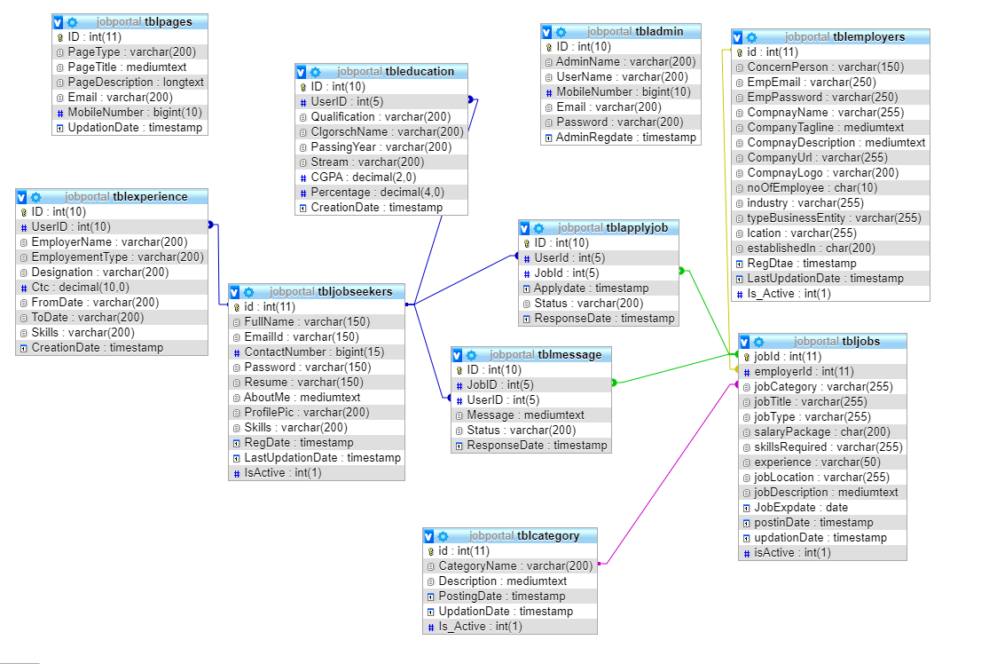

The Entity-Relationship (ER) model was originally proposed by Peter in 1976 [Chen76] as a way to unify the network and relational database views. Simply stated the ER model is a conceptual data model that views the real world as entities and relationships. A basic component of the model is the Entity-Relationship diagram which is used to visually represent data objects. Since Chen wrote his paper the model has been extended and today it is commonly used for database design for the database designer, the utility of the ER model is:

* It maps well to the relational model. The constructs used in the ER model can easily be transformed into relational tables.
* It is simple and easy to understand with a minimum of training. Therefore, the model can be used by the database designer to communicate the design to the end user.
* In addition, the model can be used as a design plan by the database developer to implement a data model in specific database management software.

**ER Notation**

There is no standard for representing data objects in ER diagrams. Each modeling methodology uses its own notation. The original notation used by Chen is widely used in academics texts and journals but rarely seen in either CASE tools or publications by non-academics. Today, there are a number of notations used; among the more common are Bachman, crow's foot, and IDEFIX.

All notational styles represent entities as rectangular boxes and relationships as lines connecting boxes. Each style uses a special set of symbols to represent the cardinality of a connection. The notation used in this document is from Martin. The symbols used for the basic ER constructs are:

* **Entities** are represented by labeled rectangles. The label is the name of the entity. Entity names should be singular nouns.
* **Relationships** are represented by a solid line connecting two entities. The name of the relationship is written above the line. Relationship names should be verbs
* **Attributes**, when included, are listed inside the entity rectangle. Attributes which are identifiers are underlined. Attribute names should be singular nouns.
* **Cardinality** of many is represented by a line ending in a crow's foot. If the crow's foot is omitted, the cardinality is one.

**Existence** is represented by placing a circle or a perpendicular bar on the line. Mandatory existence is shown by the bar (looks like a 1) next to the entity for an instance is required. Optional existence is shown by placing a circle next to the entity that is optional.

**ER Diagram**

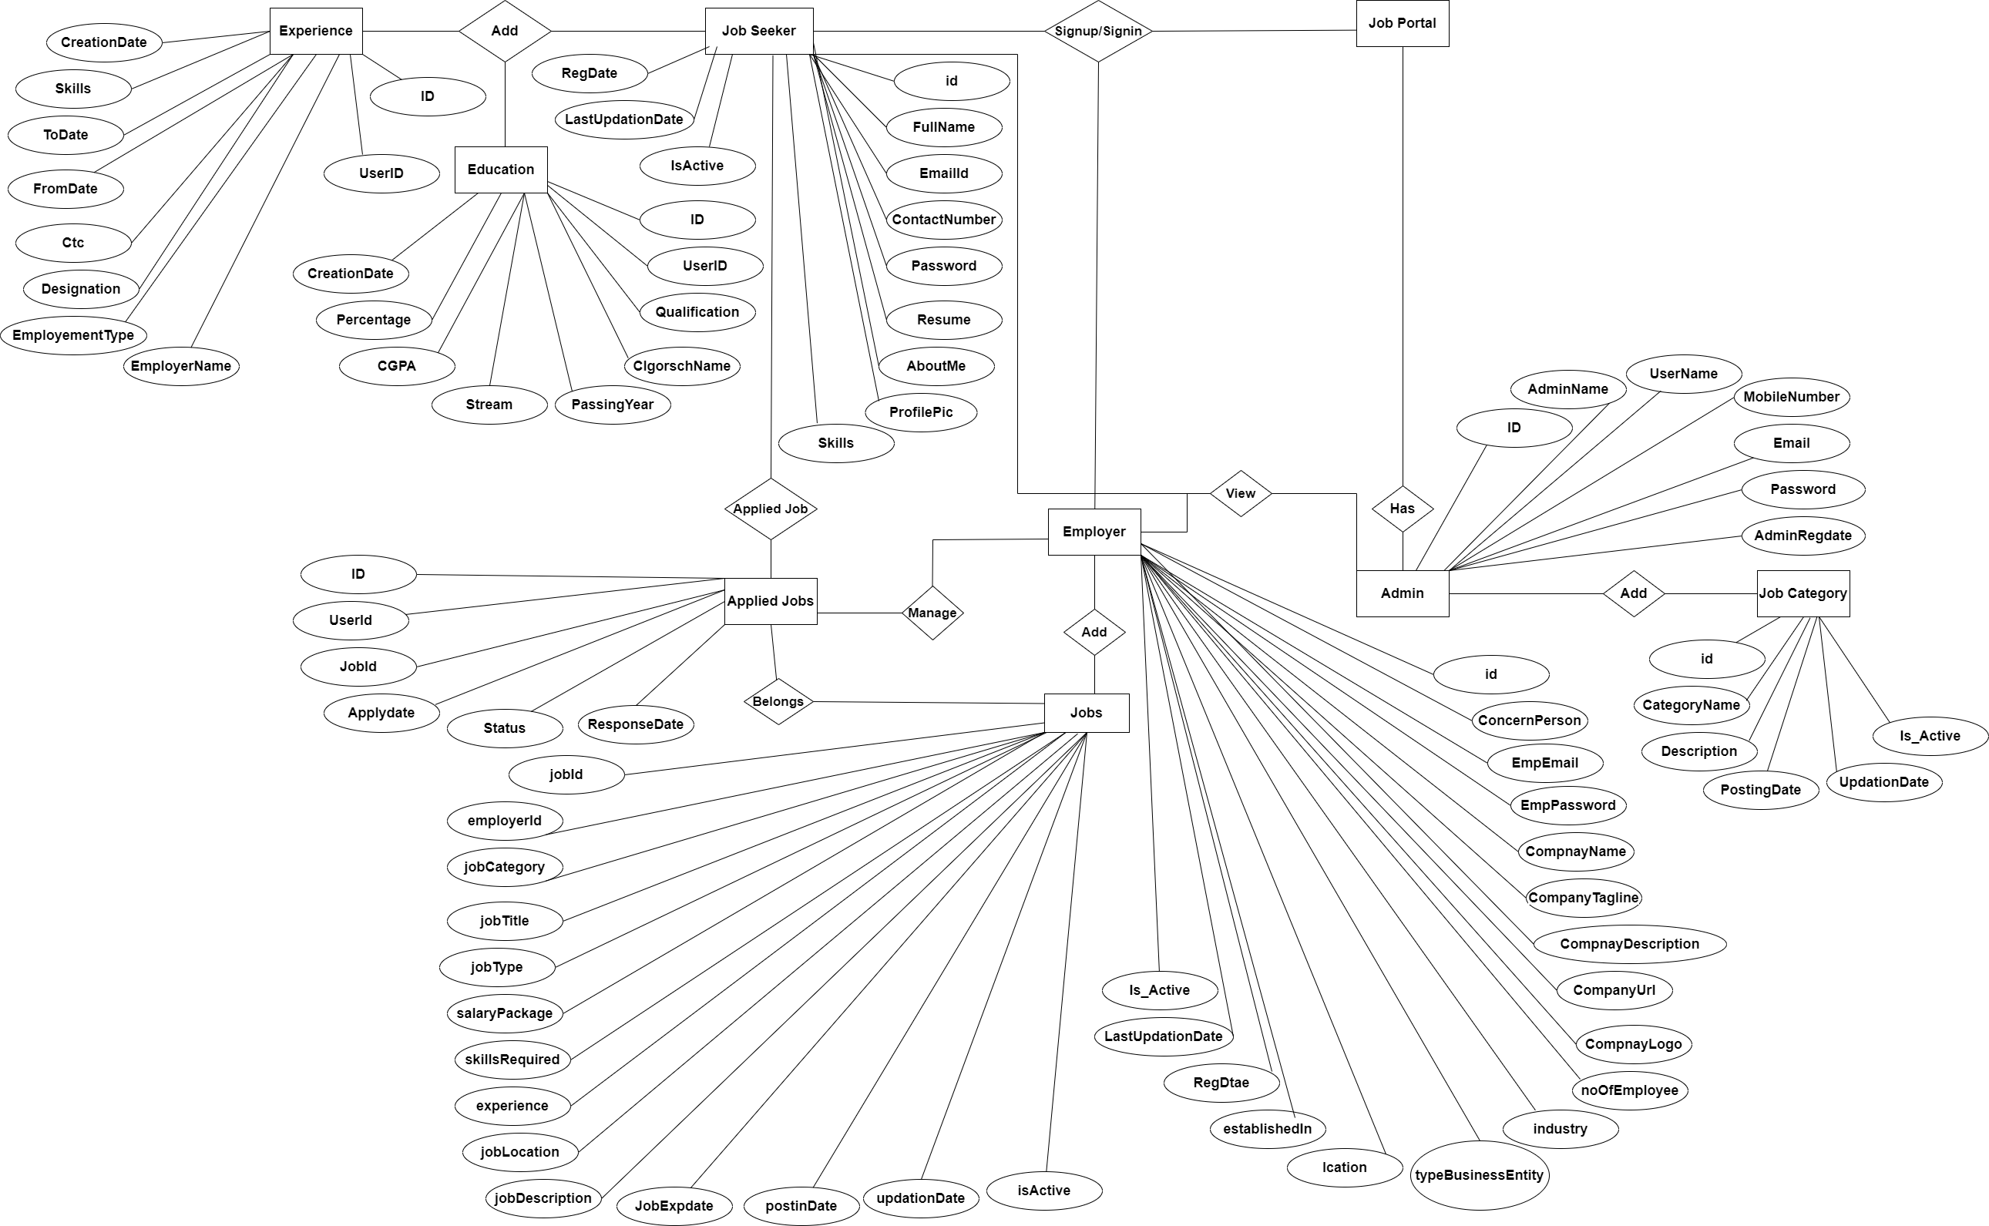

**MySQL Data Tables:**

**Admin Table:**(Table name is admin)

This store admin personal and login details.

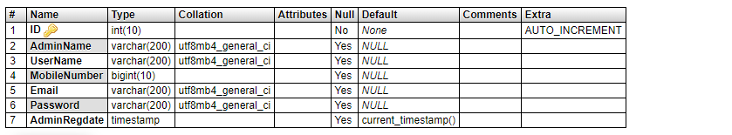

**Category Table(**Table name is tblcategory)

This table store category of jobs.

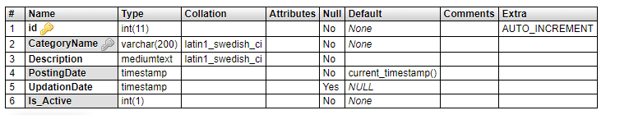

**Apply Job Table:** (Table name is tblapplyjob)

This table store the details of apply jobs.

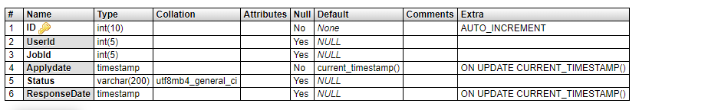

**Education Table:** (Table name is tbleducation)

This table stores the education details of candidates.

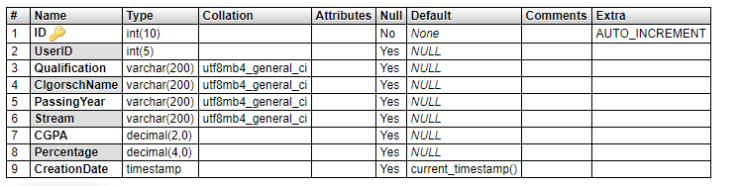

**Experience Table:** (Table name is tblexperience)

This table stores the experience details of candidates.

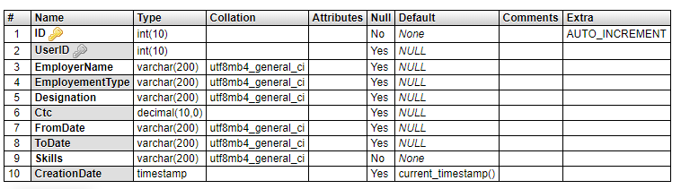

**Employers** **Table:** (Table name is tblemployers)

This table stores details of employers.

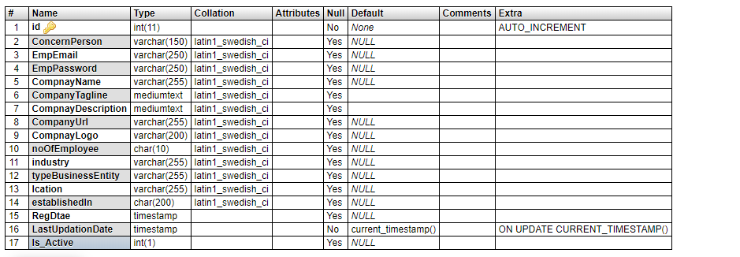

**Jobs** **Table:** (Table name is tbljobs)

This table stores details of jobs which are posted by employers.

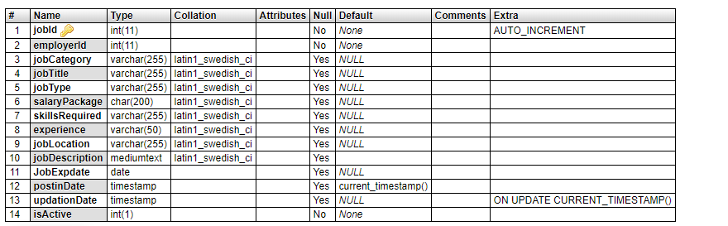

**Jobseekers** **Table:** (Table name is tbljobseekers)

This table stores details of jobseeker.

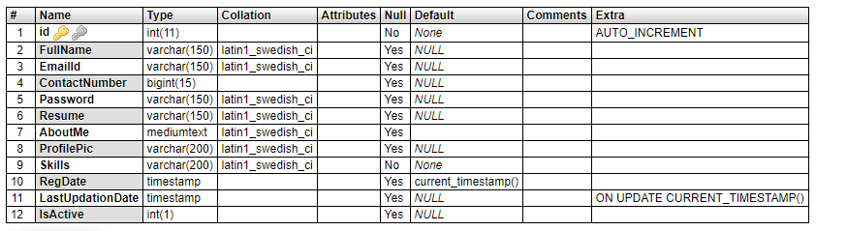

**Message** **Table:** (Table name is tblmessage)

This table stores message detail which is send by employer to jobseeker.

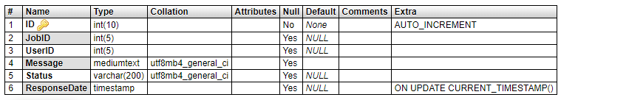

**Pages** **Table:** (Table name is tblpages)

This table stores about us and contact us details.

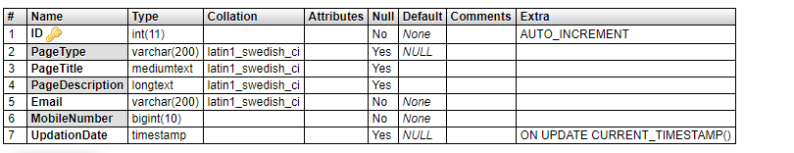

**Implementation and System Testing**

After all phase have been perfectly done, the system will be implemented to the server and the system can be used.

**System Testing**

The goal of the system testing process was to determine all faults in our project .The program was subjected to a set of test inputs and many explanations were made and based on these explanations it will be decided whether the program behaves as expected or not. Our Project went through two levels of testing

1. Unit testing

2. Integration testing

**UNIT TESTING**

Unit testing is commenced when a unit has been created and effectively reviewed .In order to test a single module we need to provide a complete environment i.e. besides the section we would require

* The procedures belonging to other units that the unit under test calls
* Non local data structures that module accesses
* A procedure to call the functions of the unit under test with appropriate parameters

**1. Test for the admin module**

* **Testing admin login form-**This form is used for log in of administrator of the system. In this form we enter the username and password if both are correct administration page will open otherwise if any of data is wrong it will get redirected back to the login page and again ask the details.
* **Report Generation:** admin can generate report from the main database.

**INTEGRATION TESTING**

In the Integration testing we test various combination of the project module by providing the input.

The primary objective is to test the module interfaces in order to confirm that no errors are occurring when one module invokes the other module.

**EVALUATION**

**Project URL:** [**http://localhost/vpms**](http://localhost/vpms)

**Home Page**

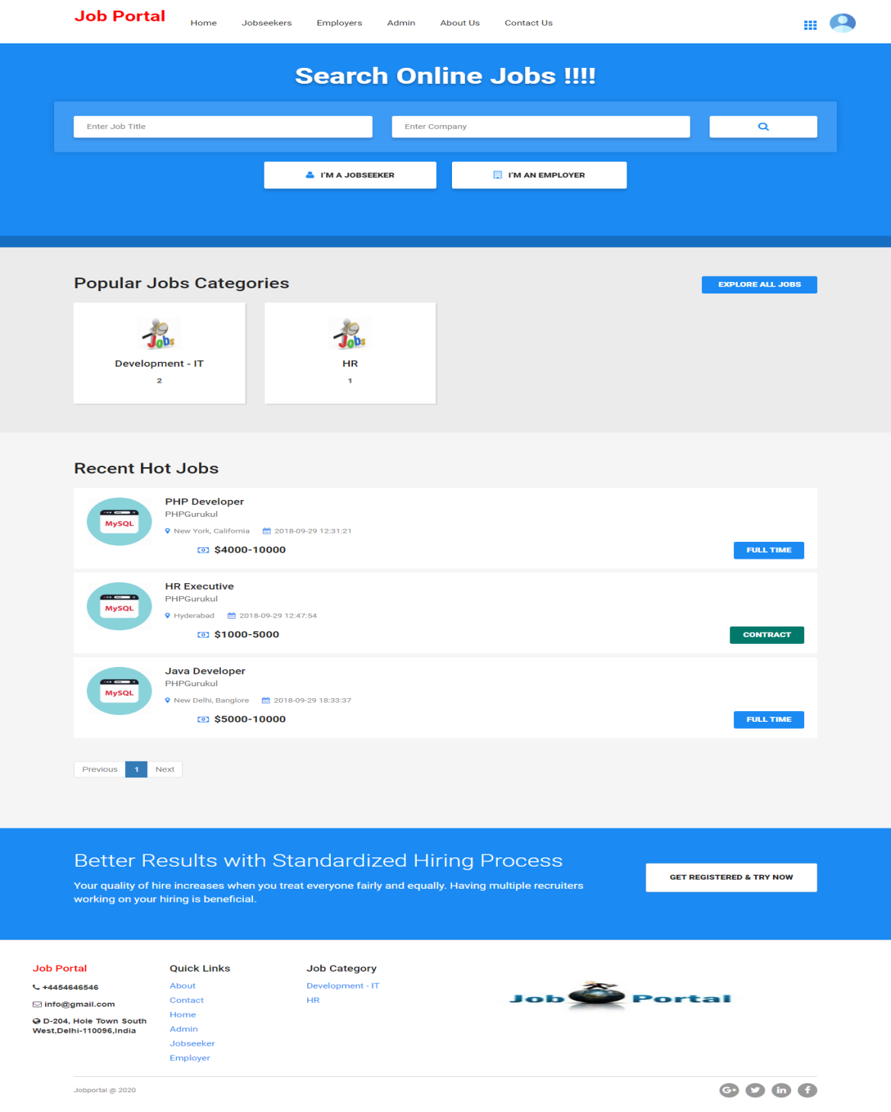

**Admin**

Login Page

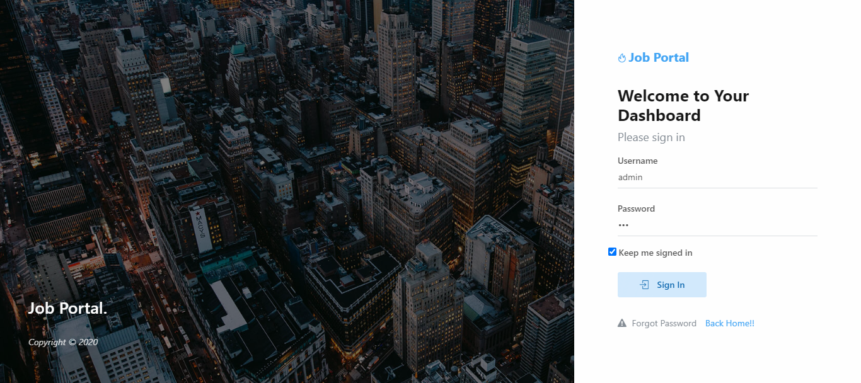

Dashboard

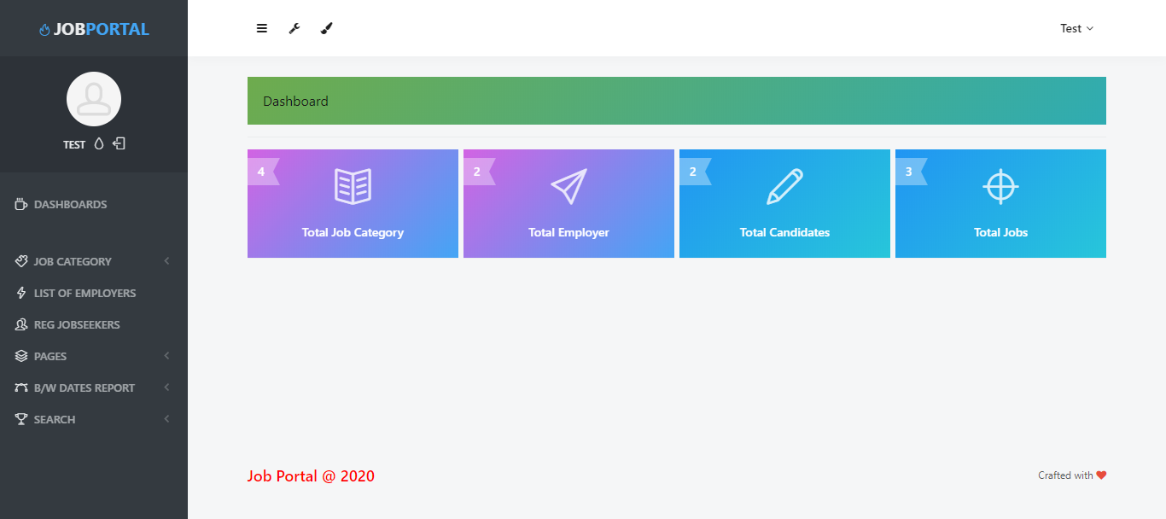

Profile

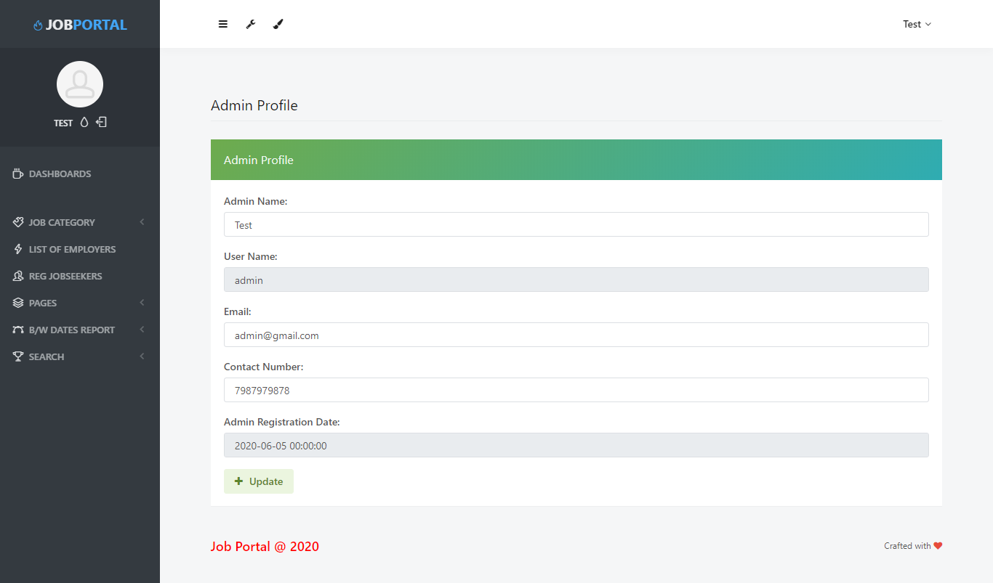

Change Password

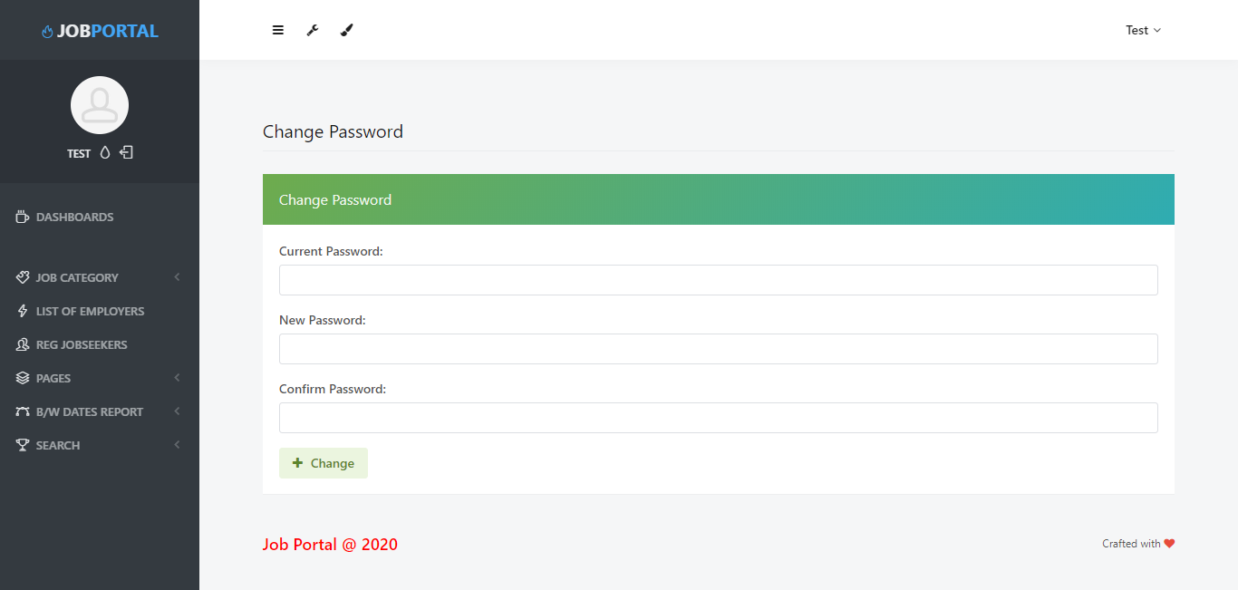

Add Job Category

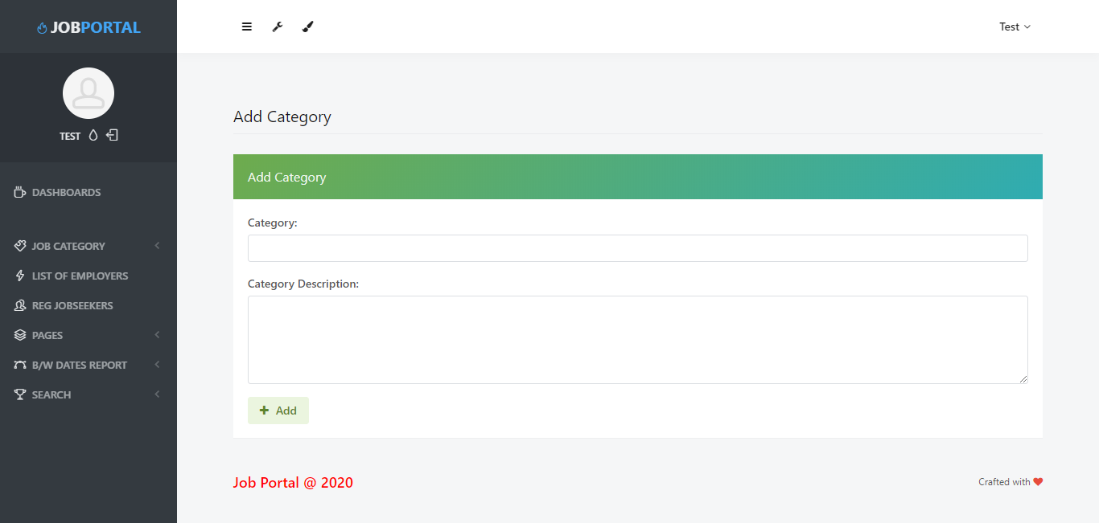

Manage Job Category

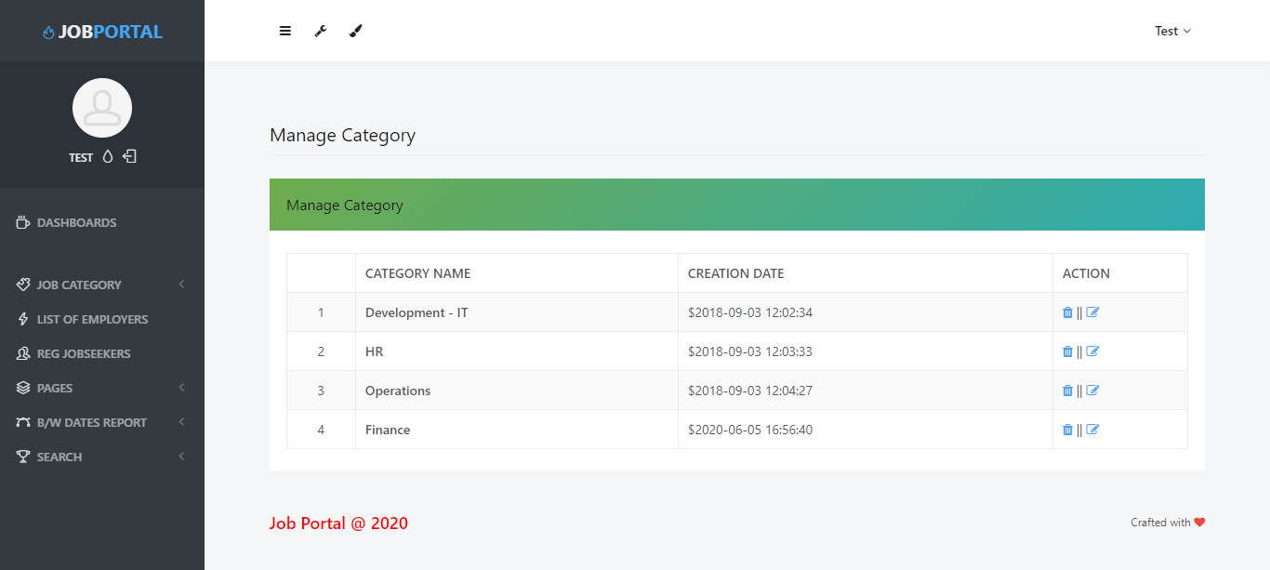

Update Job Category

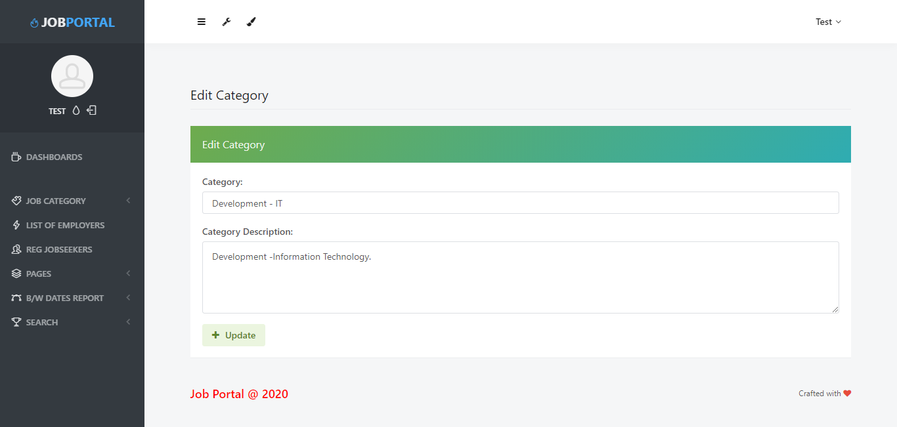

List of Employers

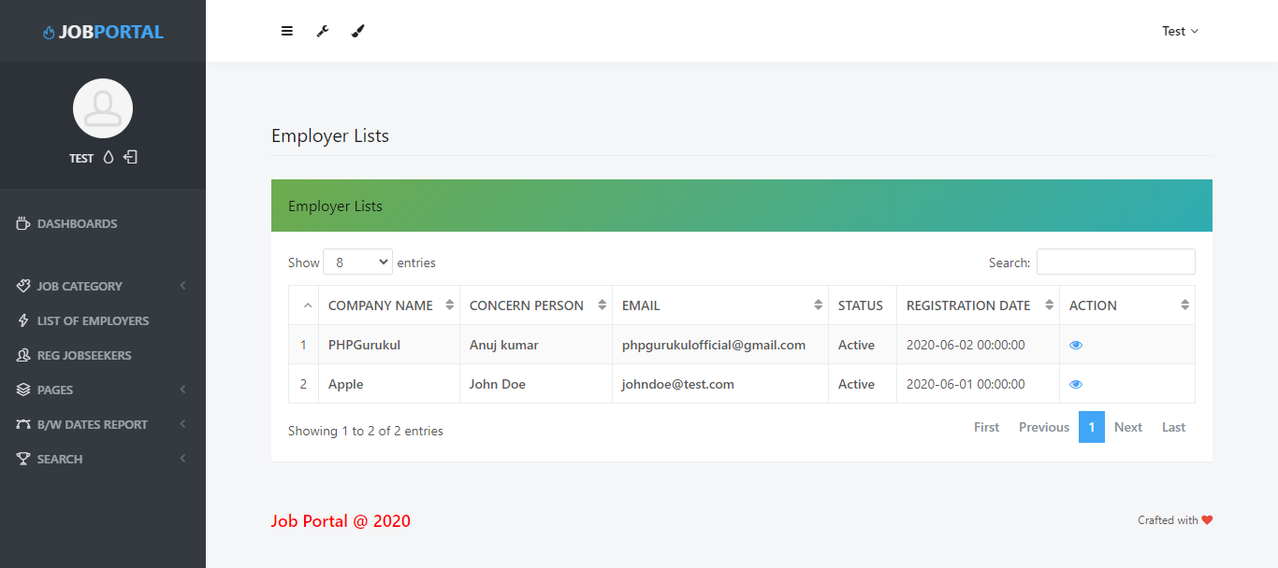

View Single detail of Employer

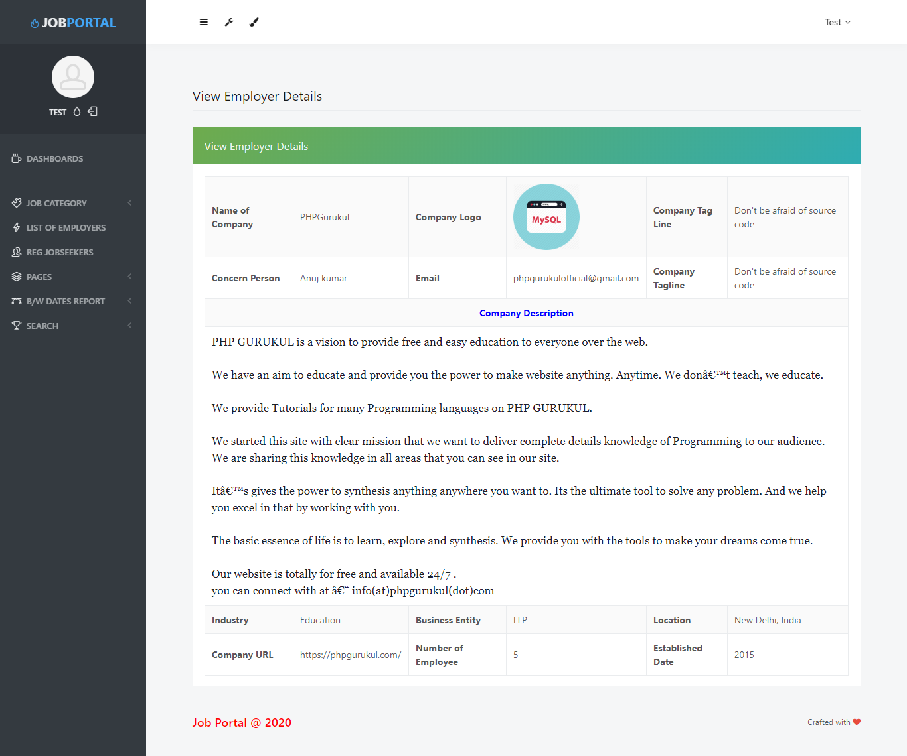

List of Registered Candidates (Jobseeker)

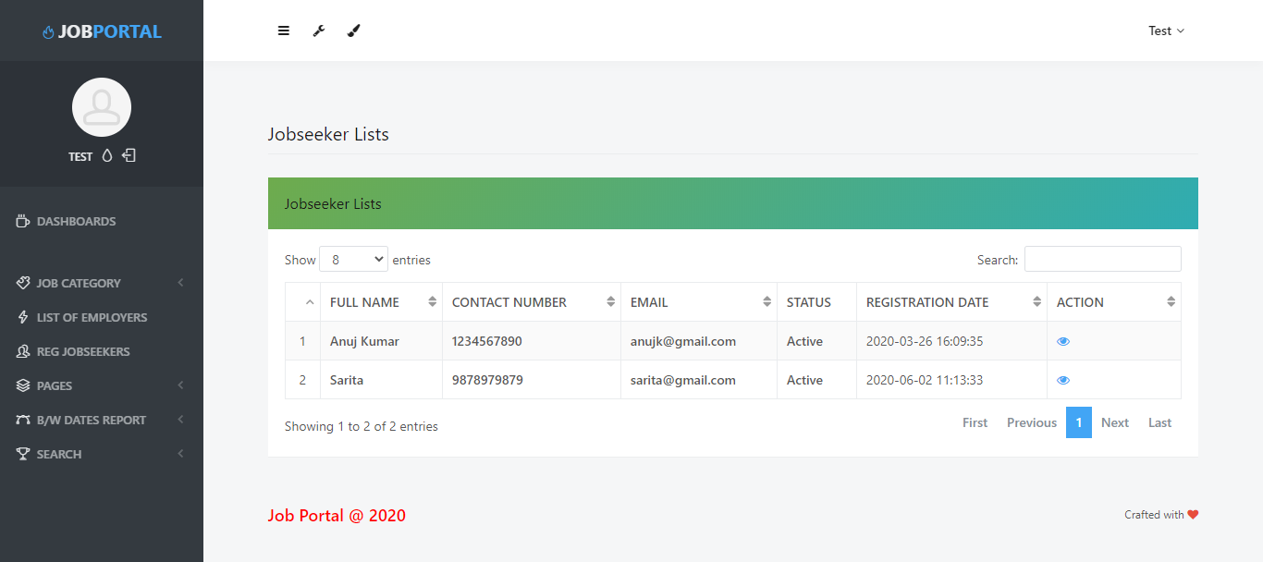

View Single detail of Jobseeker

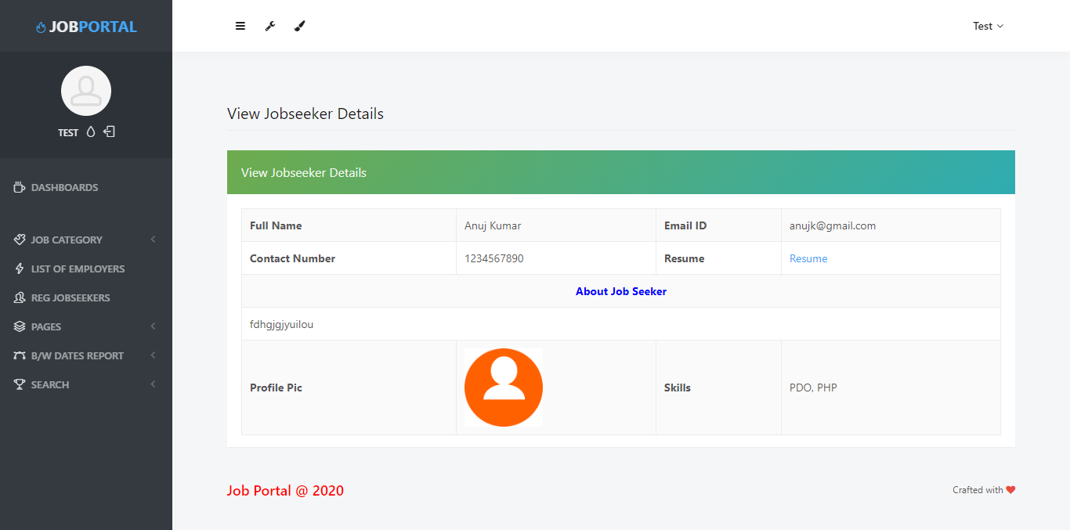

About Us Page

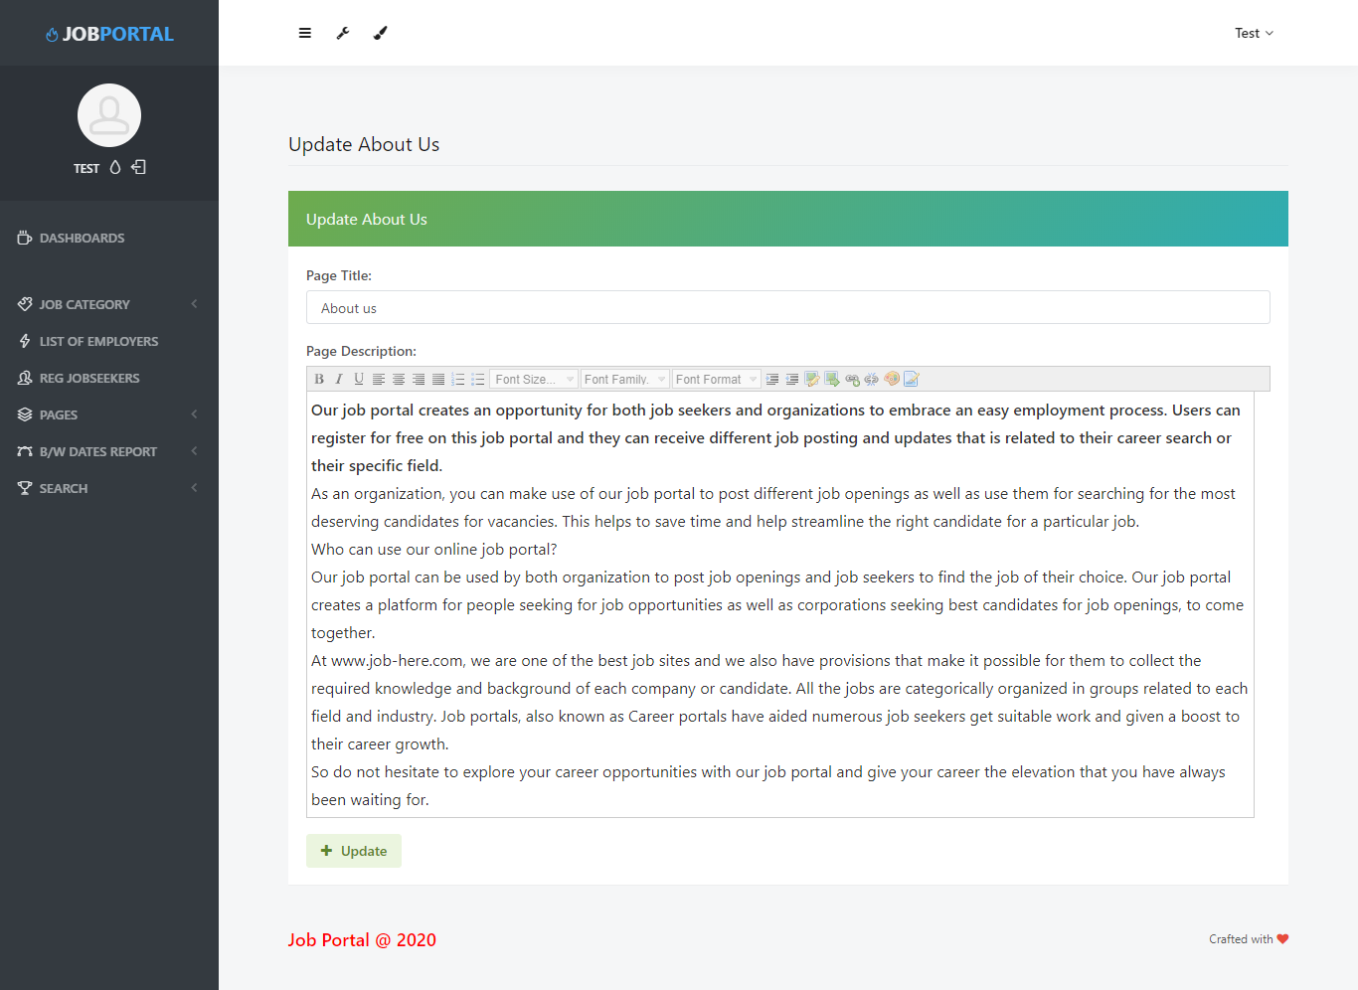

Contact Us Page

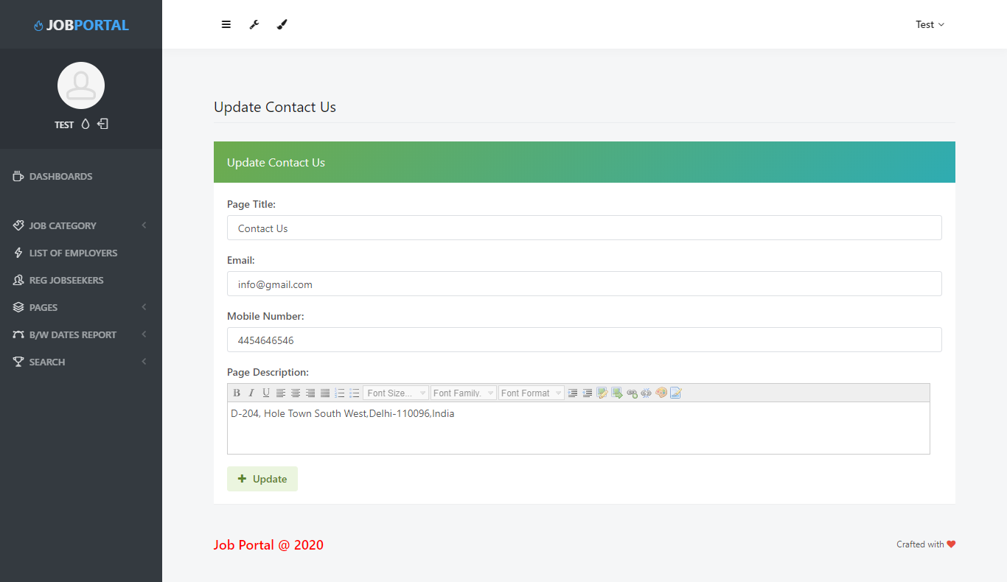

Employer Report

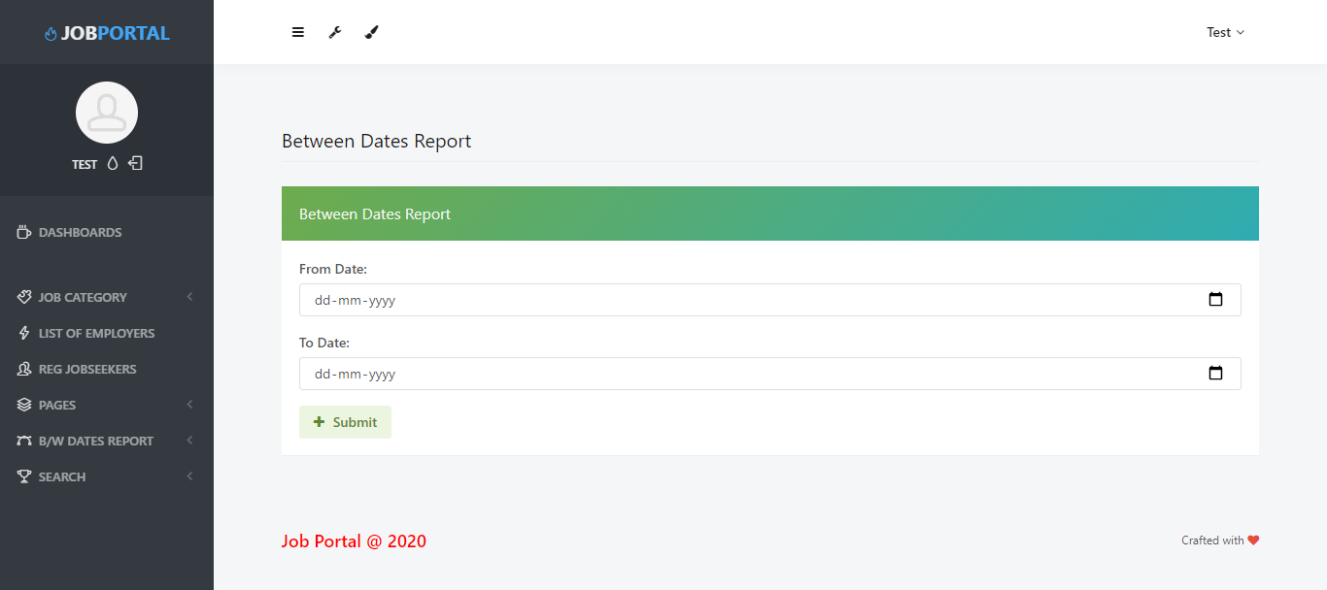

View between Dates Employer Report

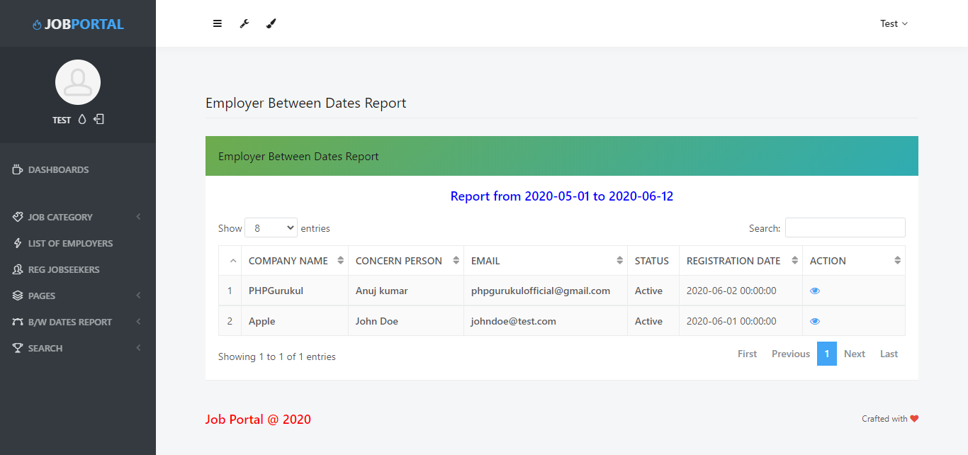

Candidates Report

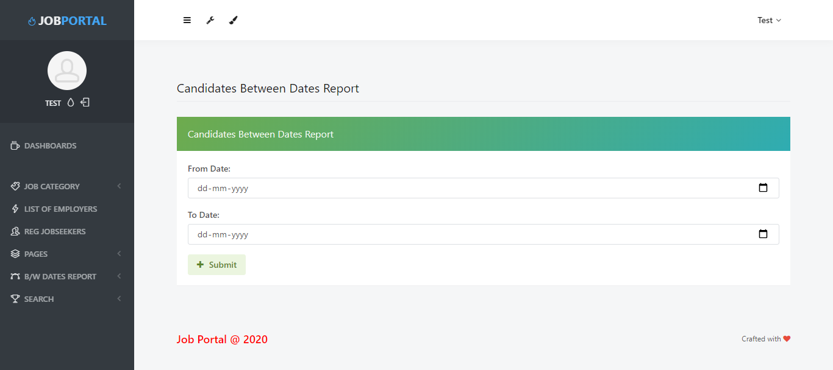

View between Dates Candidates Report

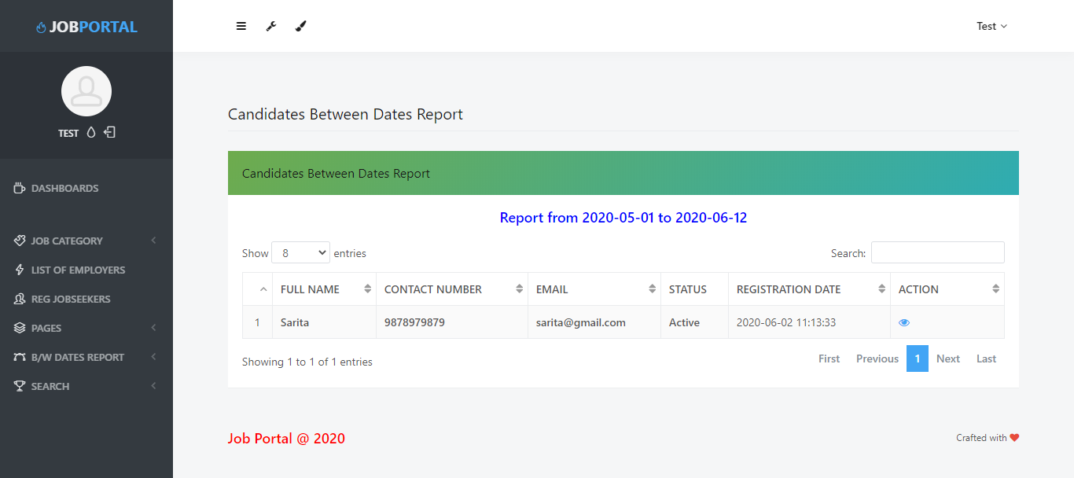

Employer Search

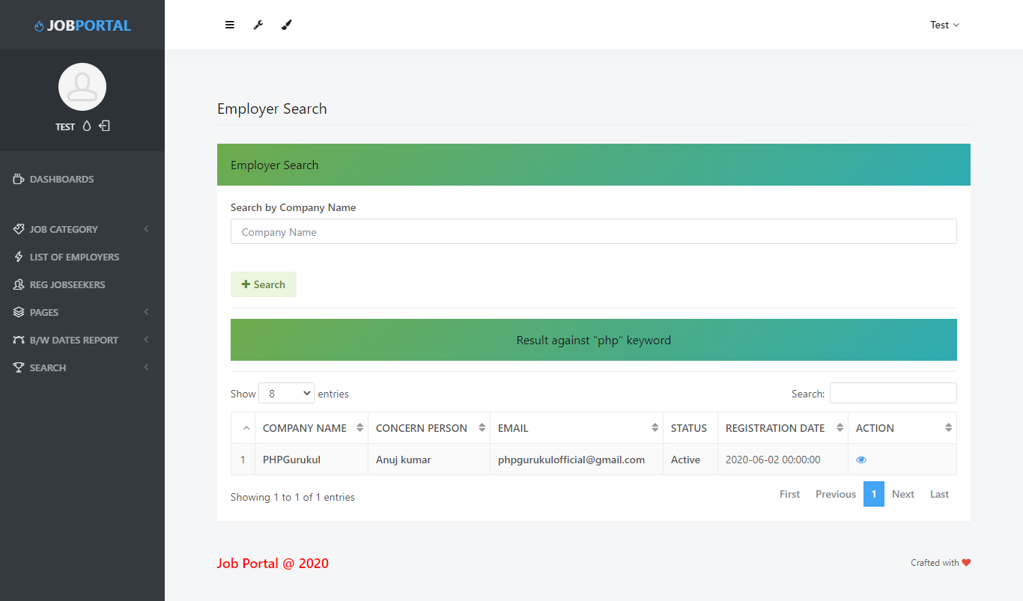

Candidates Search

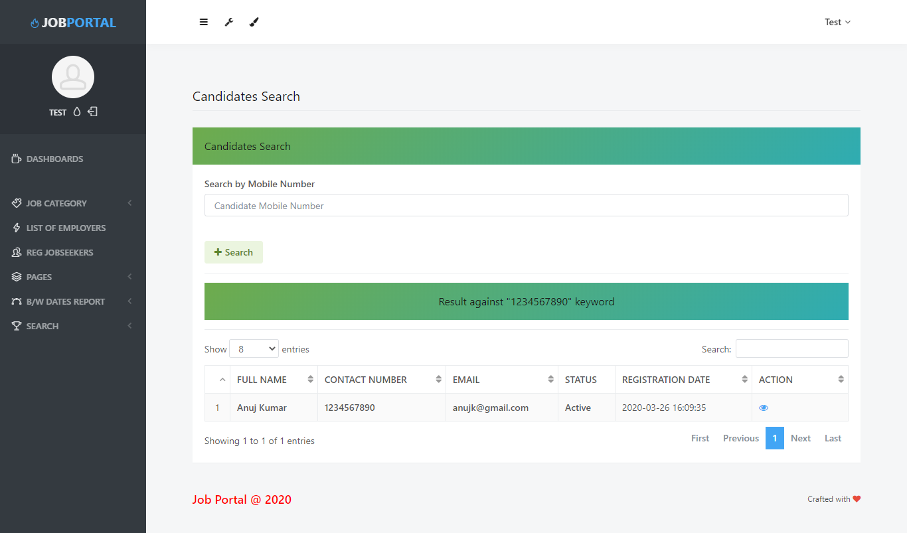

Forgot Password

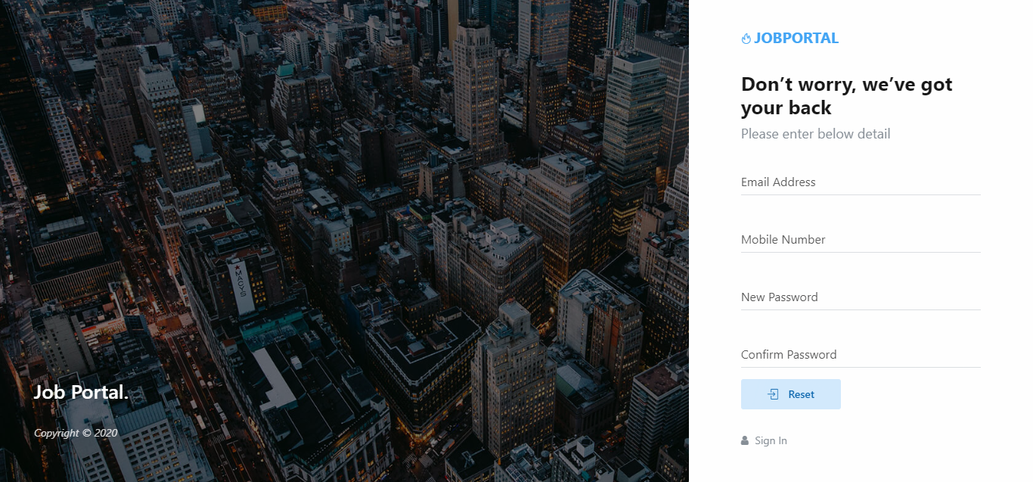

**Jobseeker**

Signup

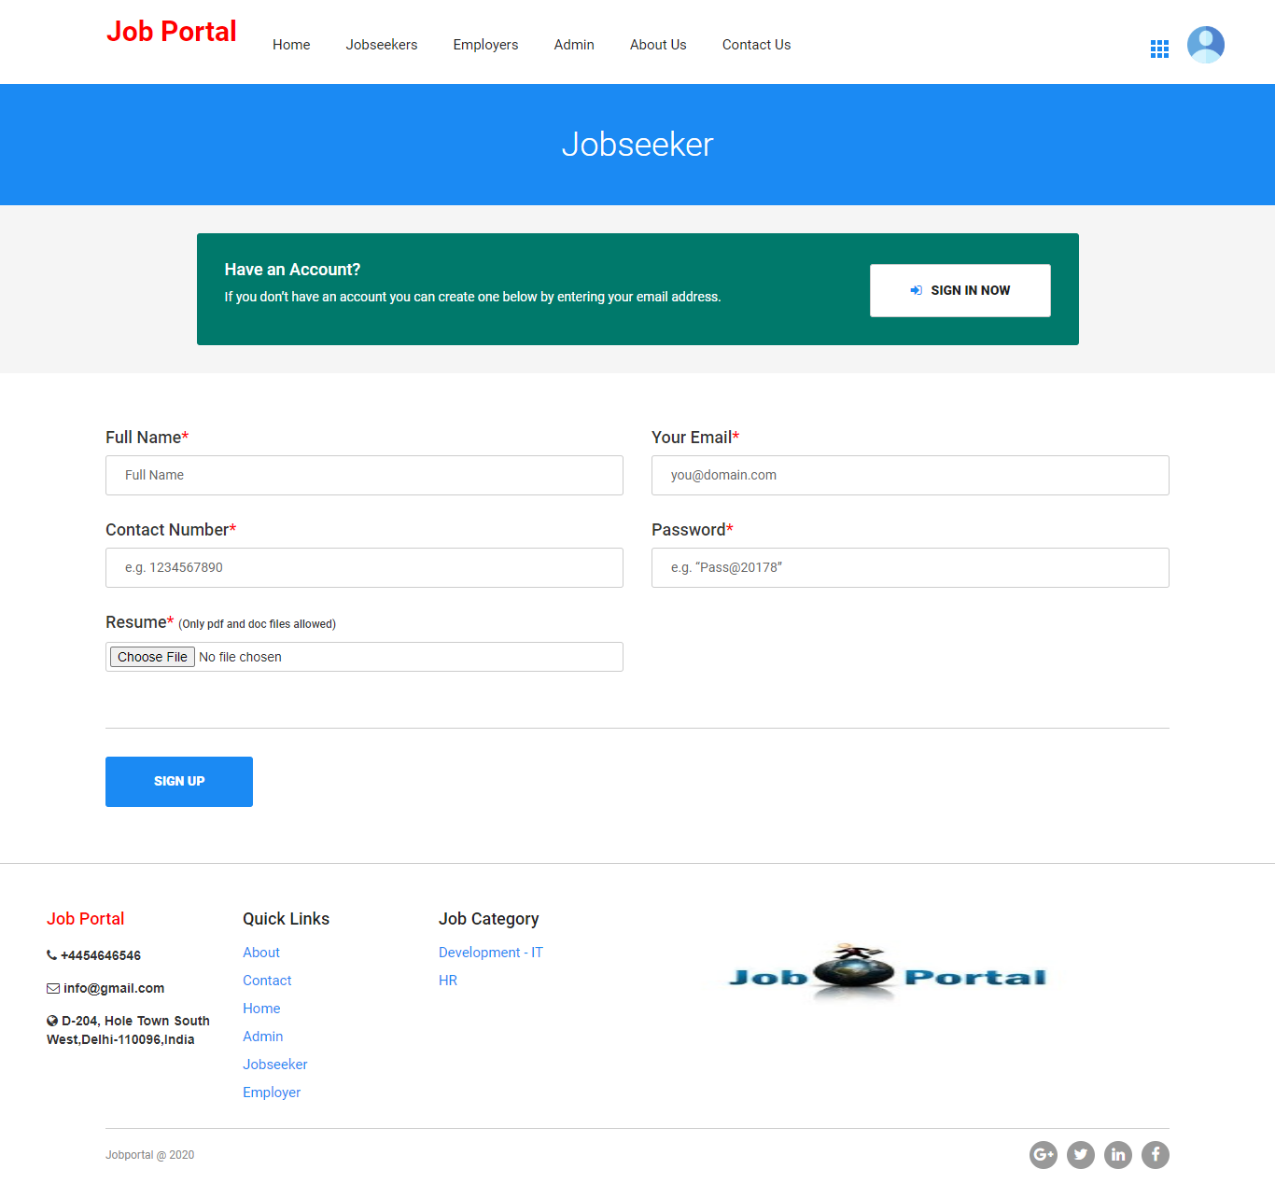

Sign in

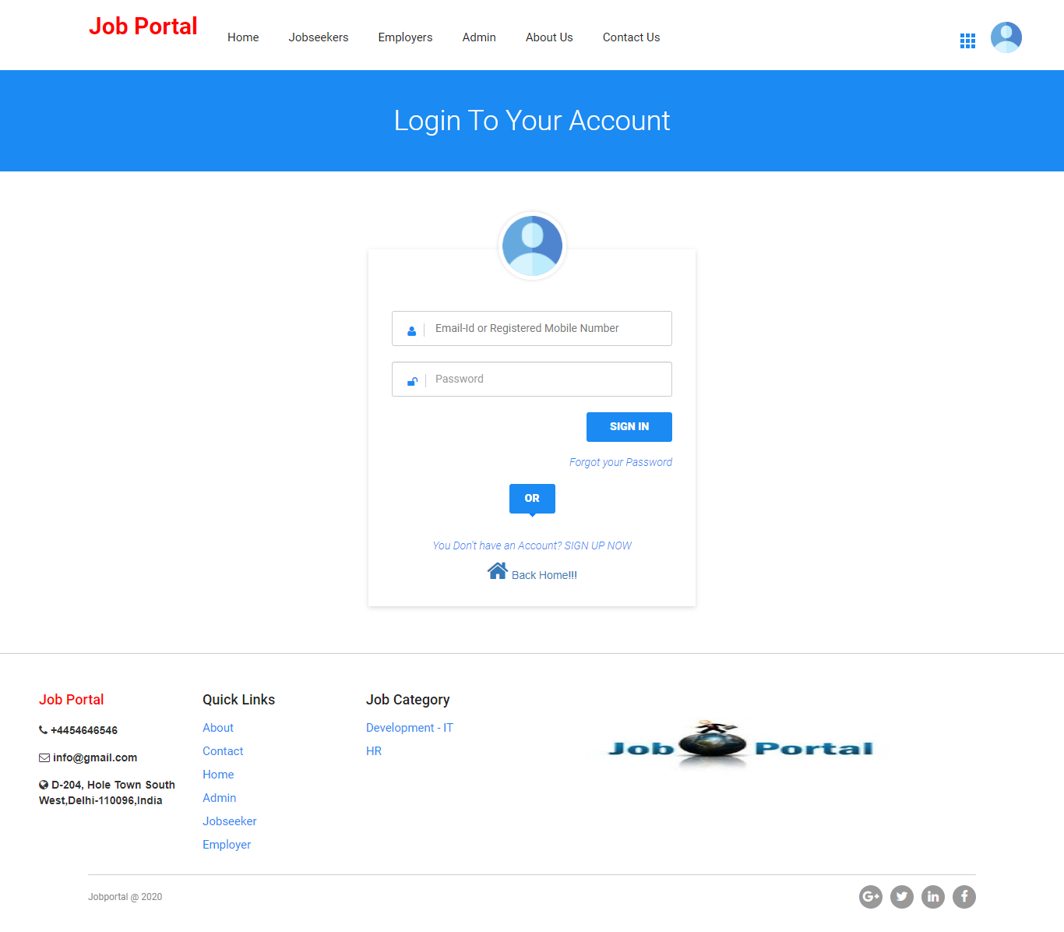

Profile

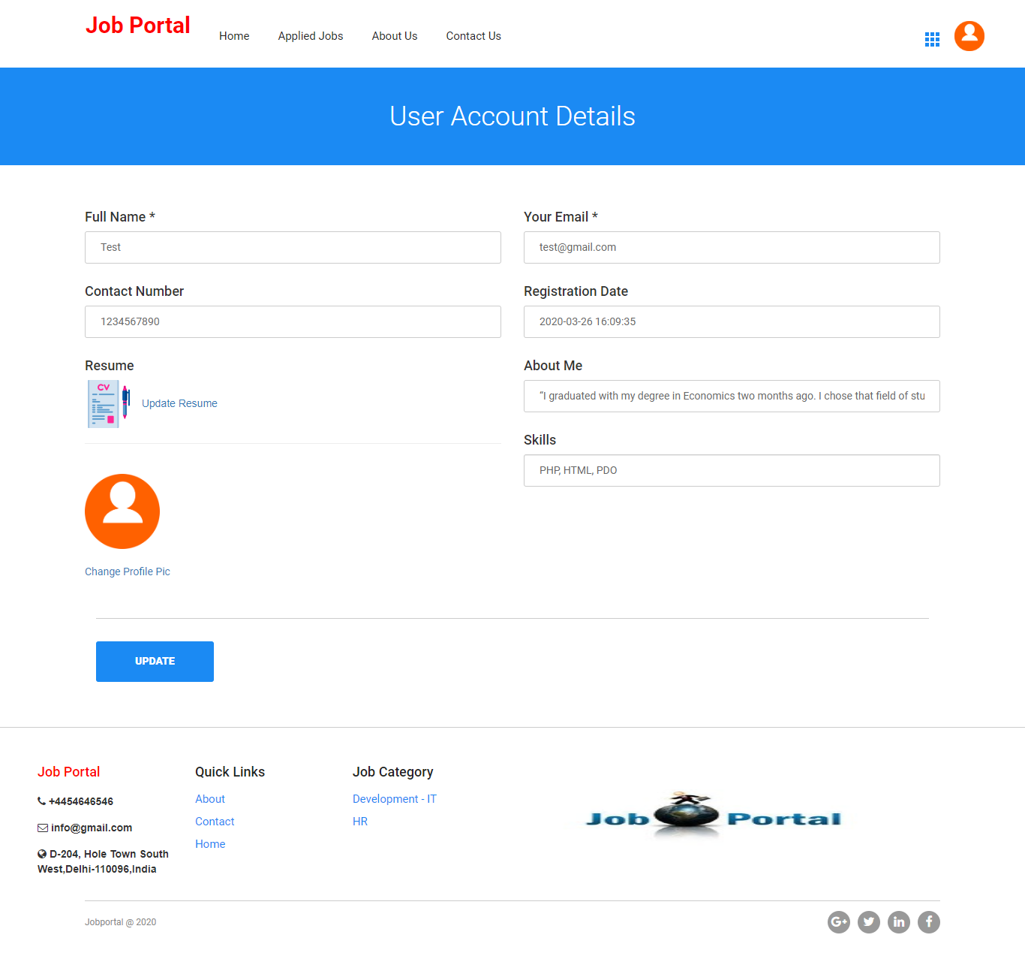

Job Seeker Details

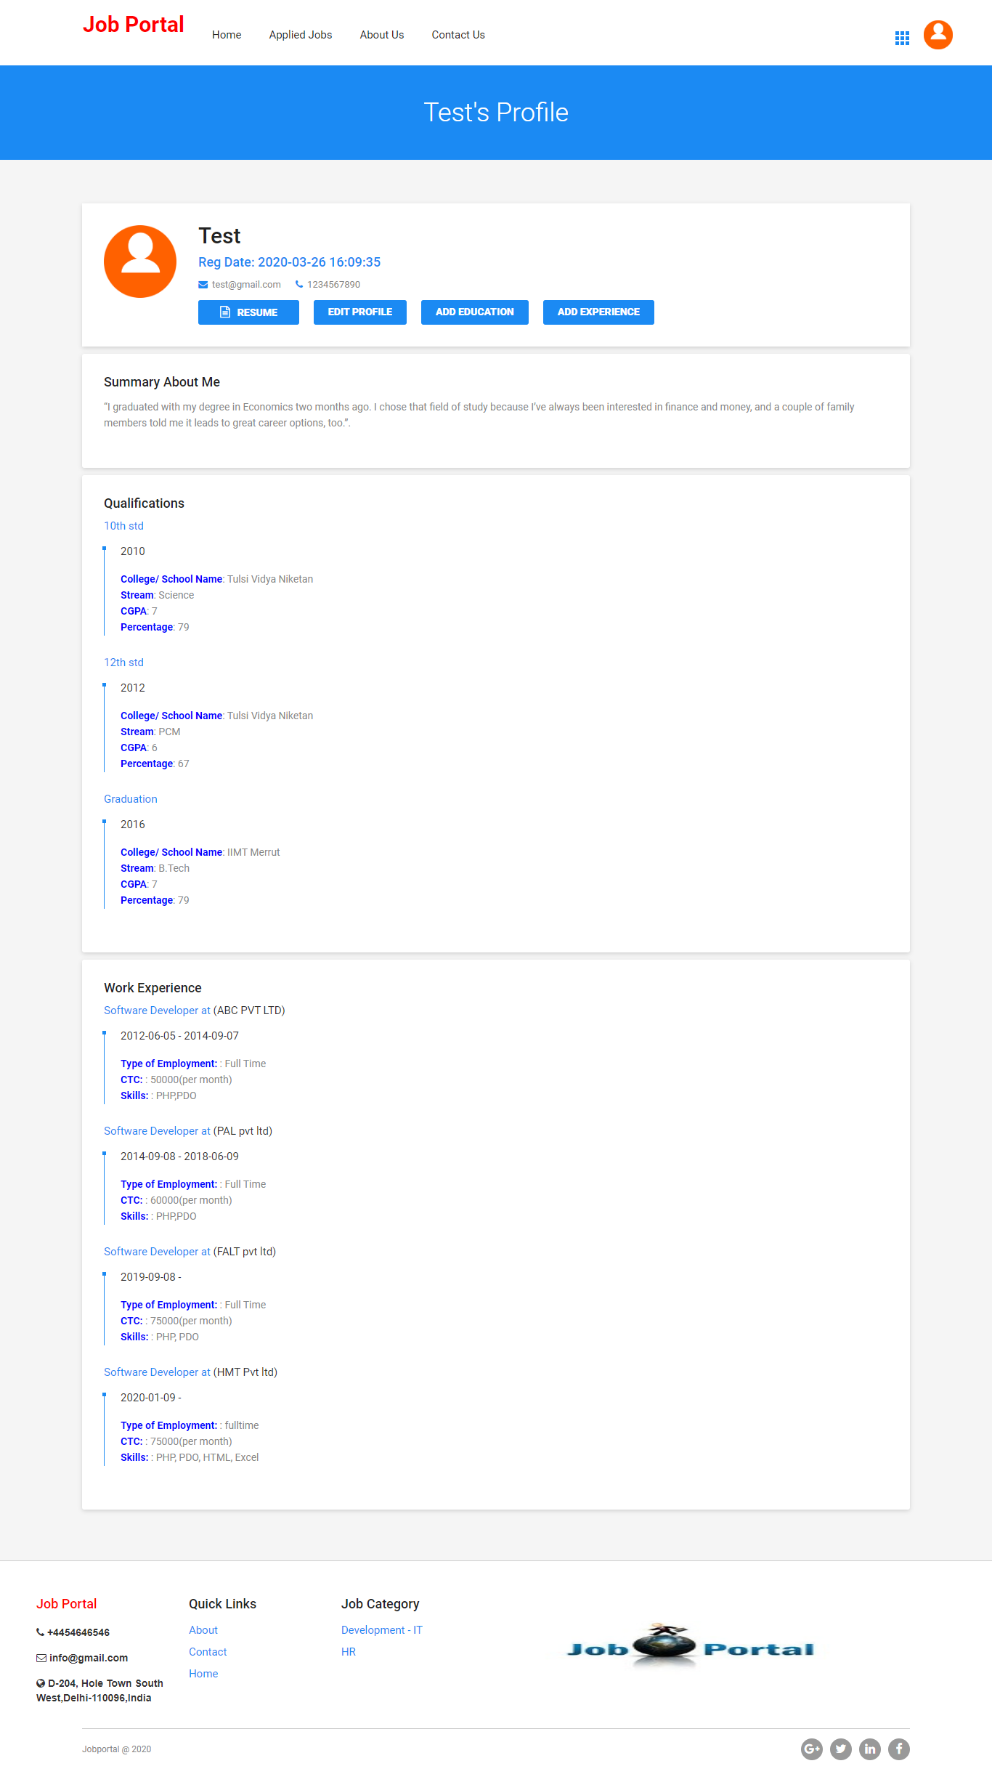

Add Education

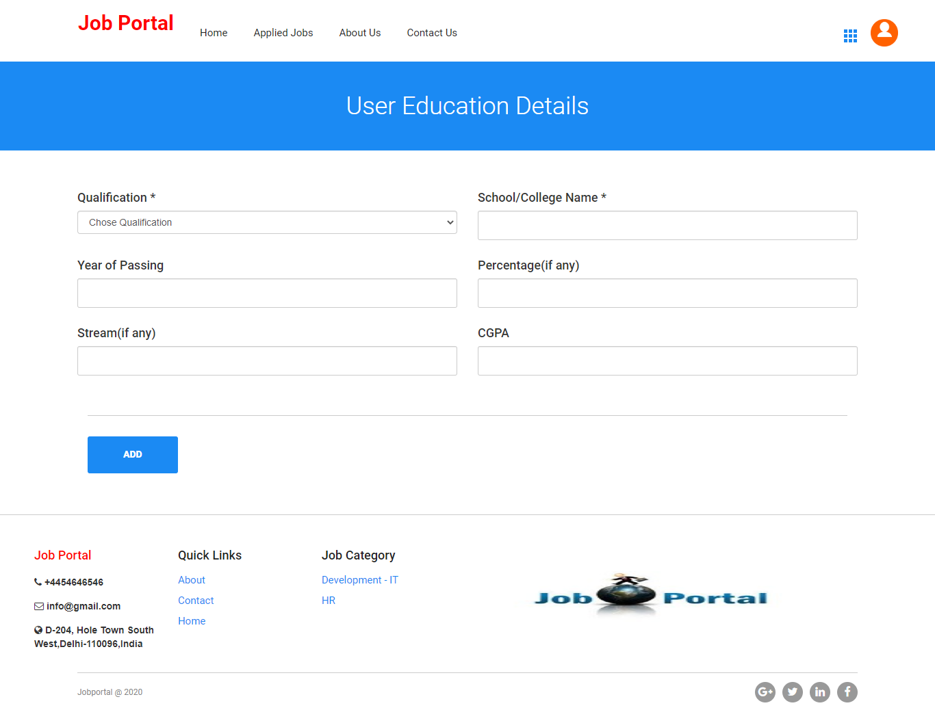

Add Experience

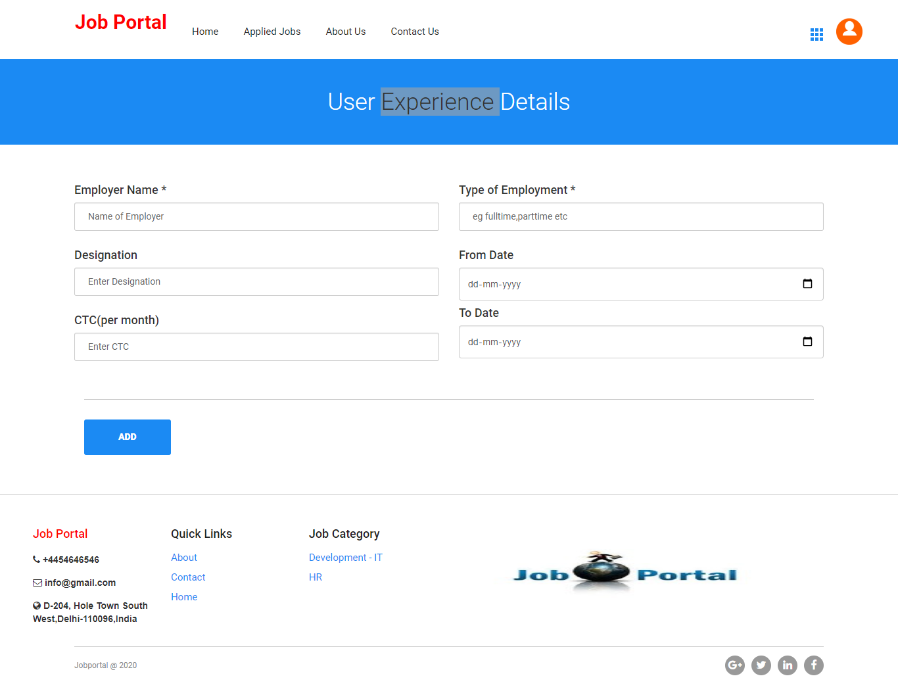

Applied Jobs details

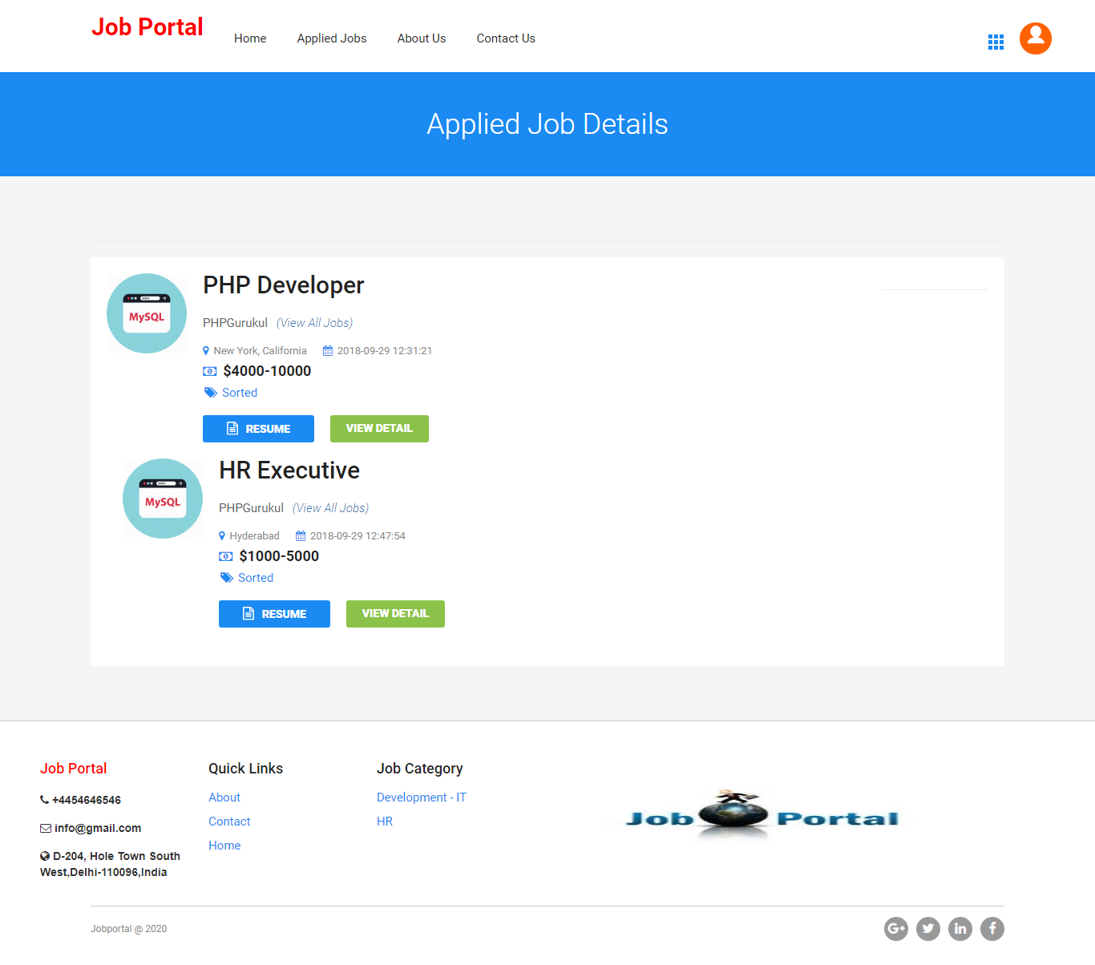

View Details of Applied Jobs

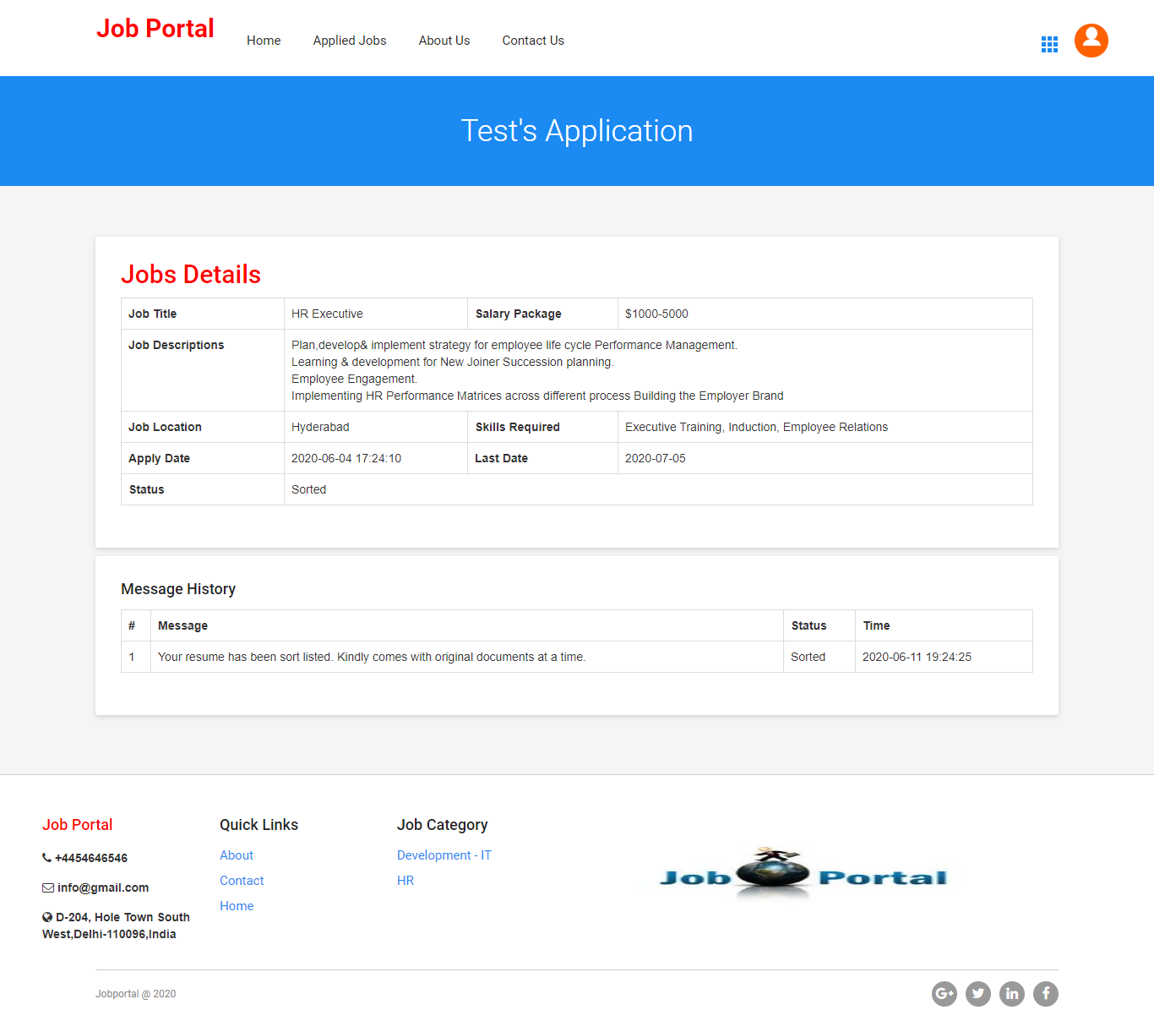

Apply Job Details

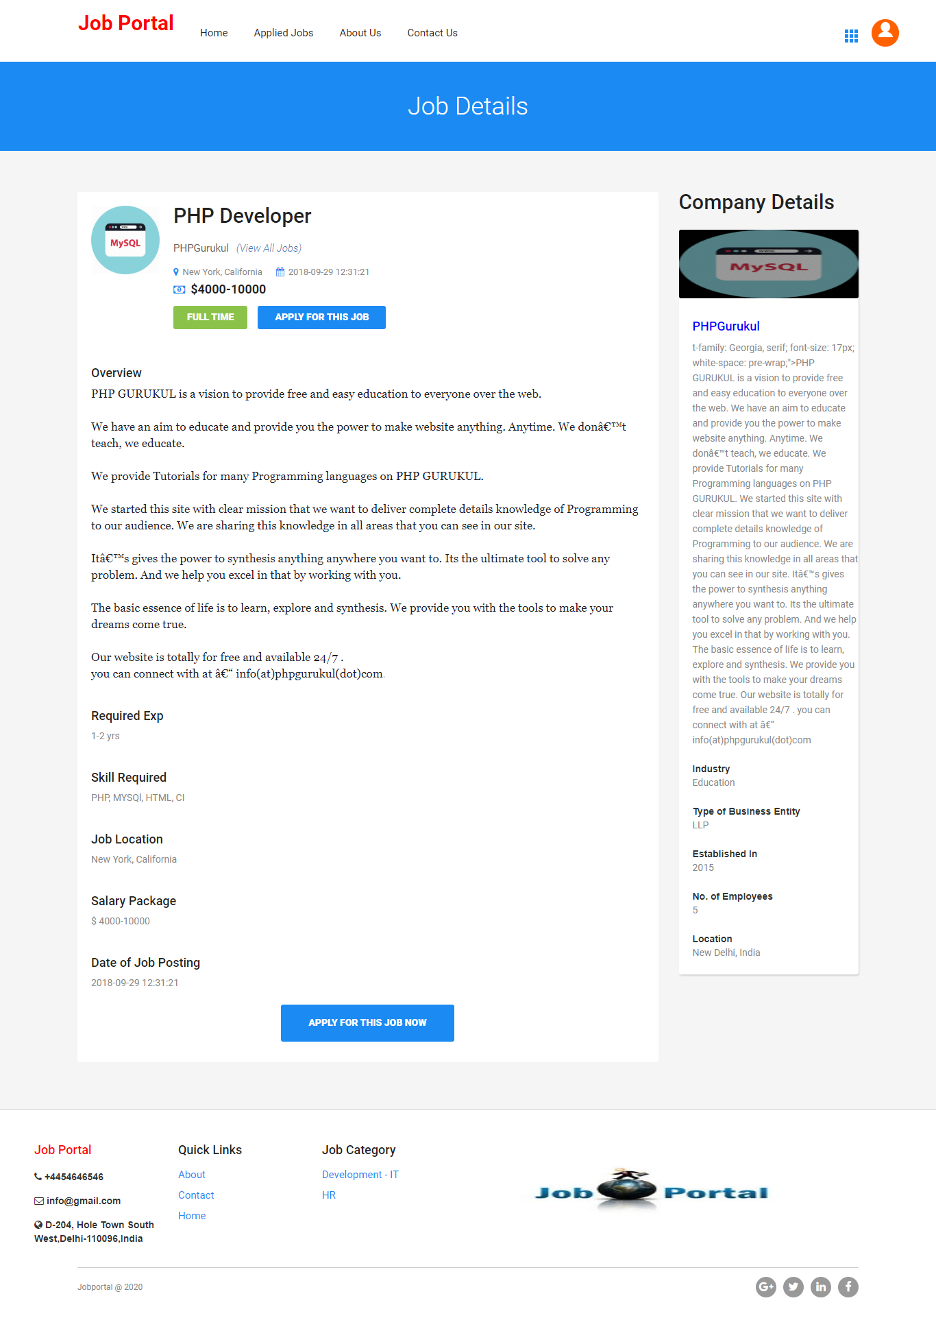

**Employer**

Signup

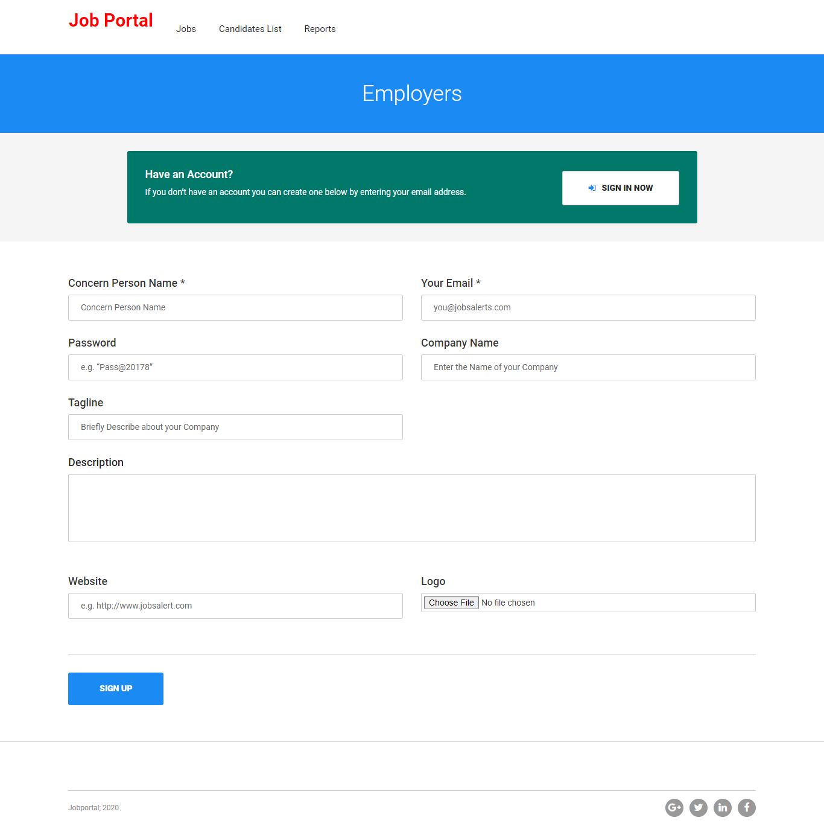

Sign in

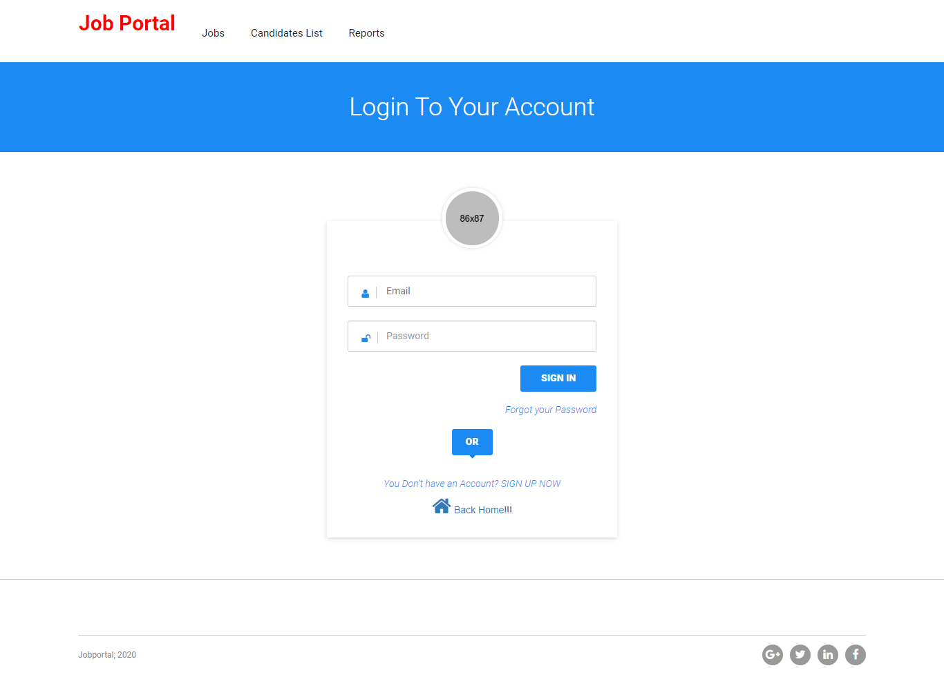

Home Page

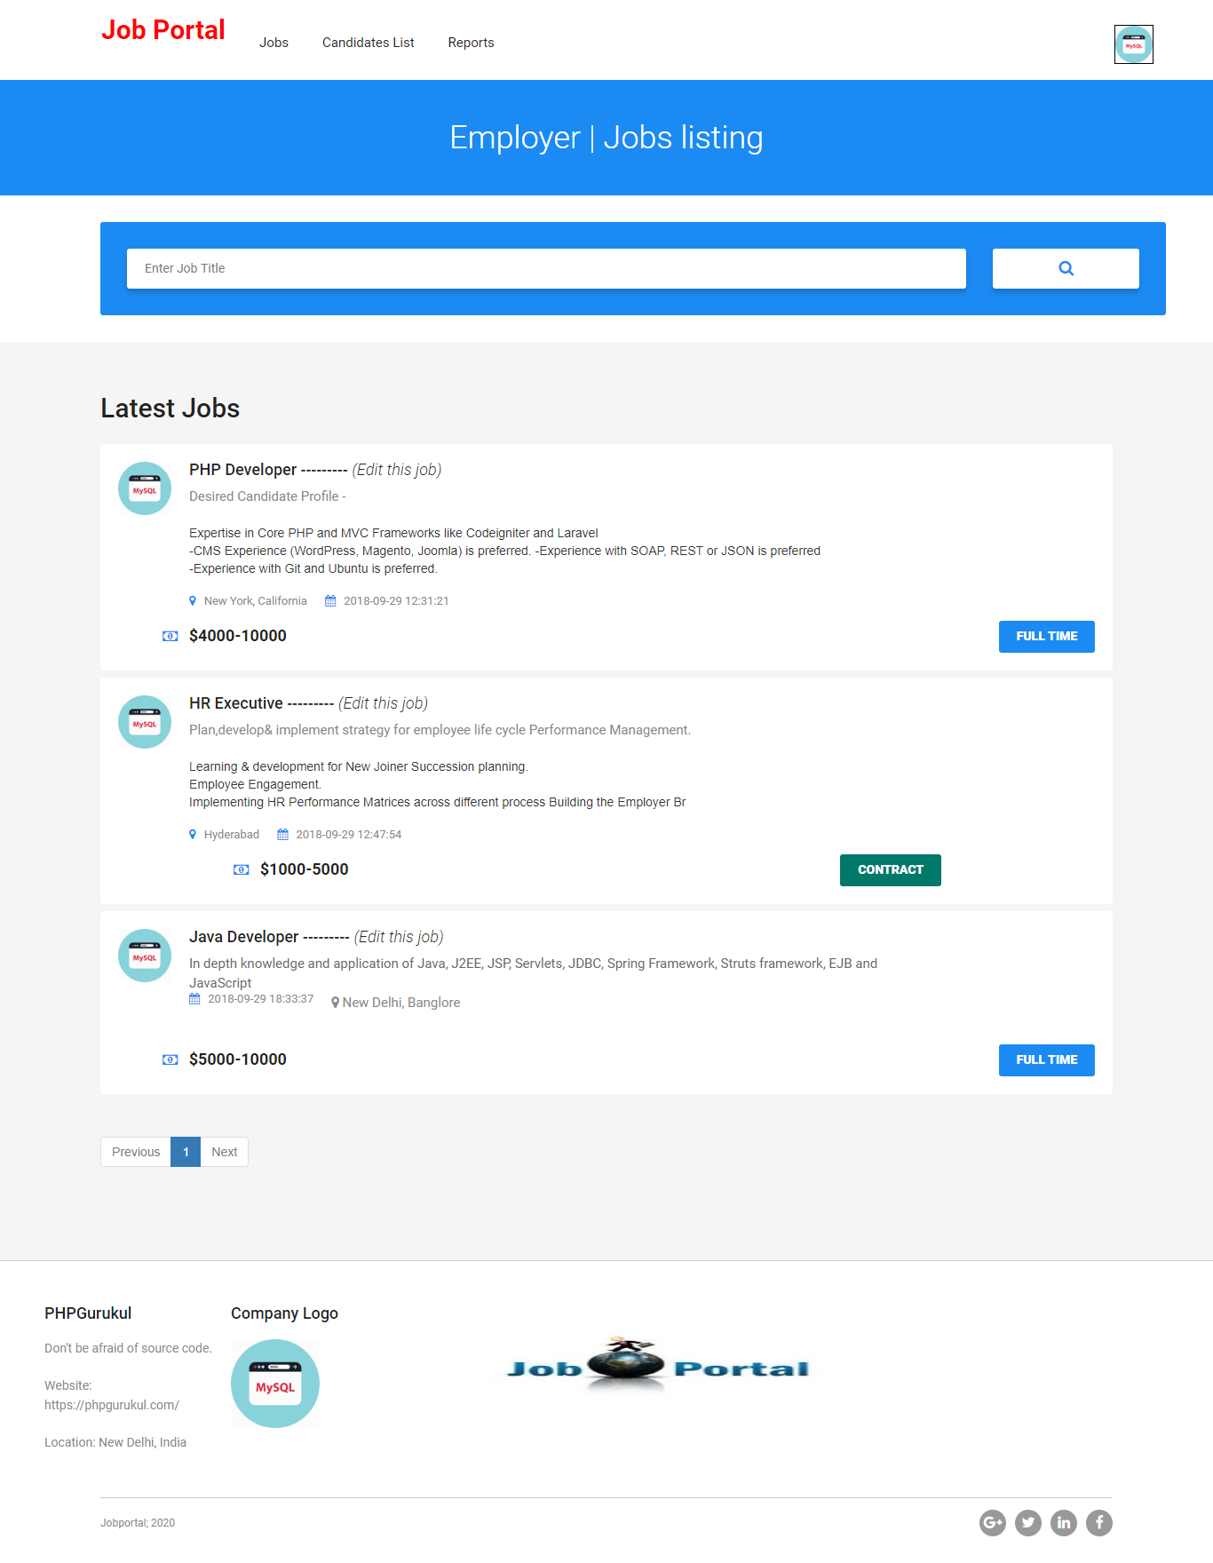

Update Job Details

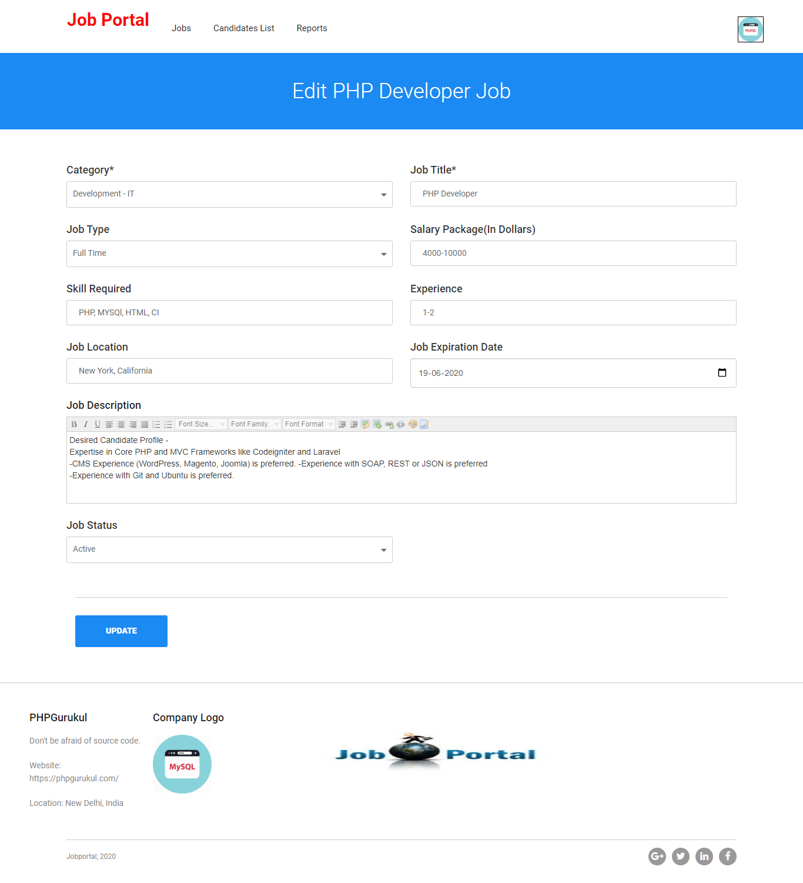

Profile

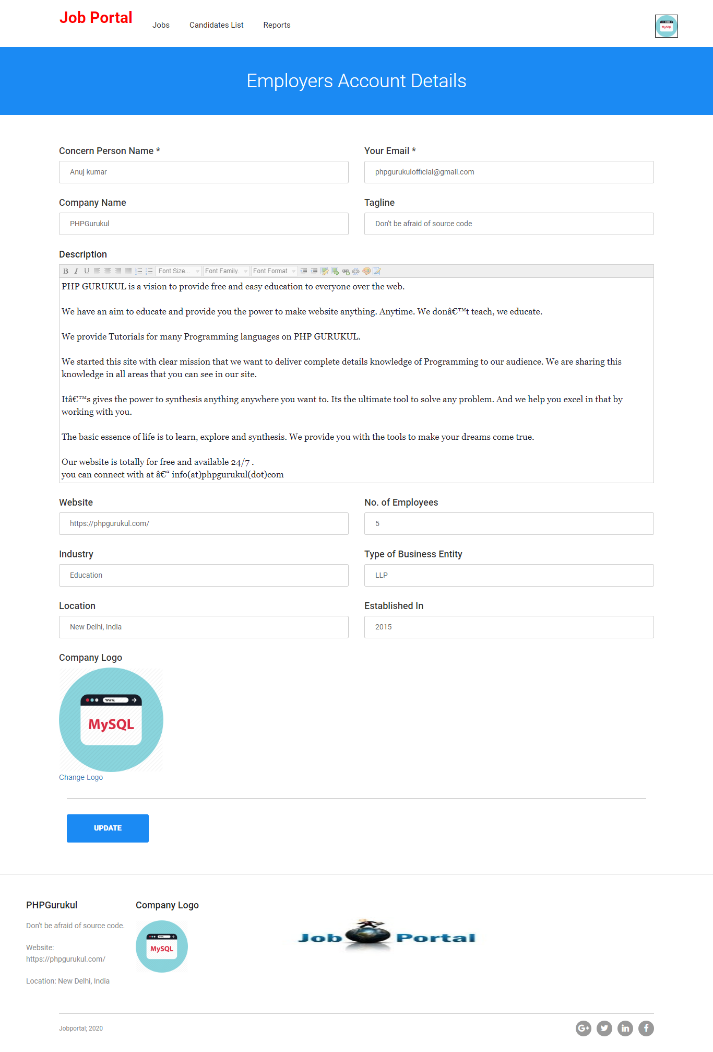

Change Password

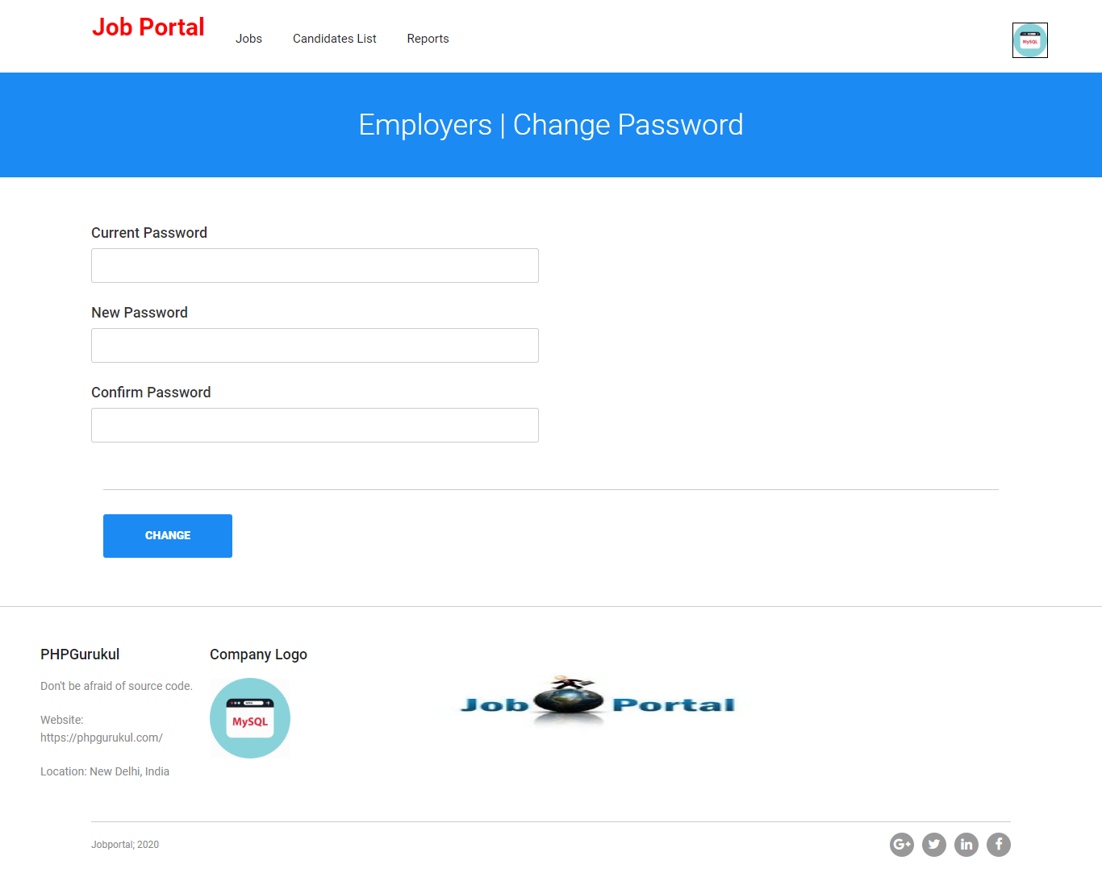

Post Job

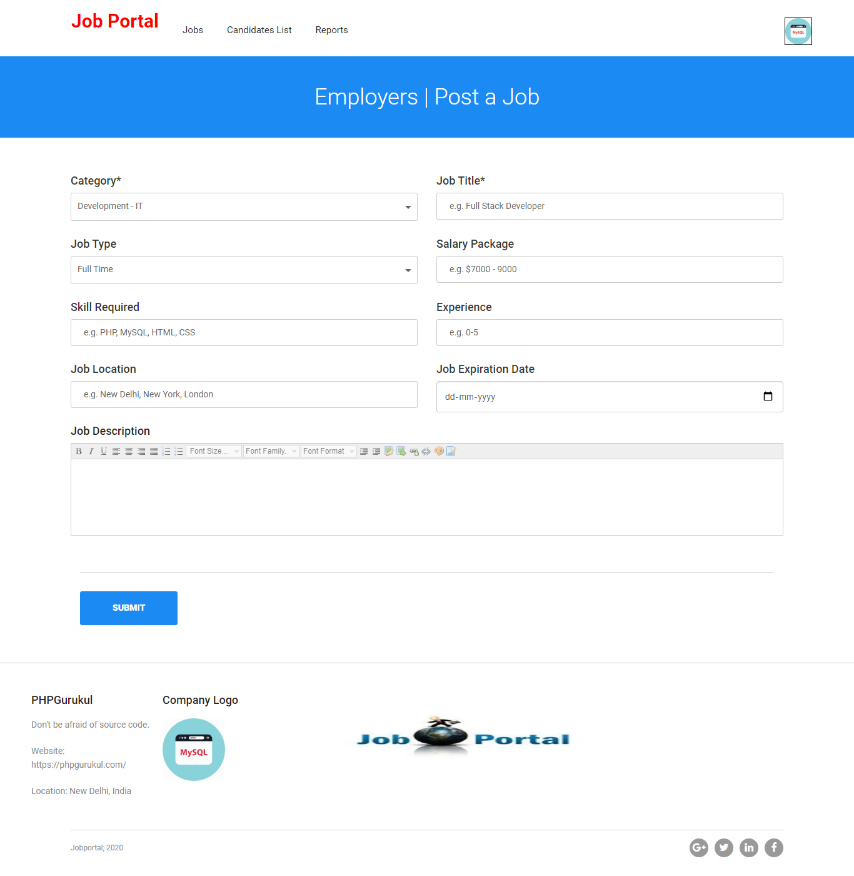

Manage Job



Candidates List

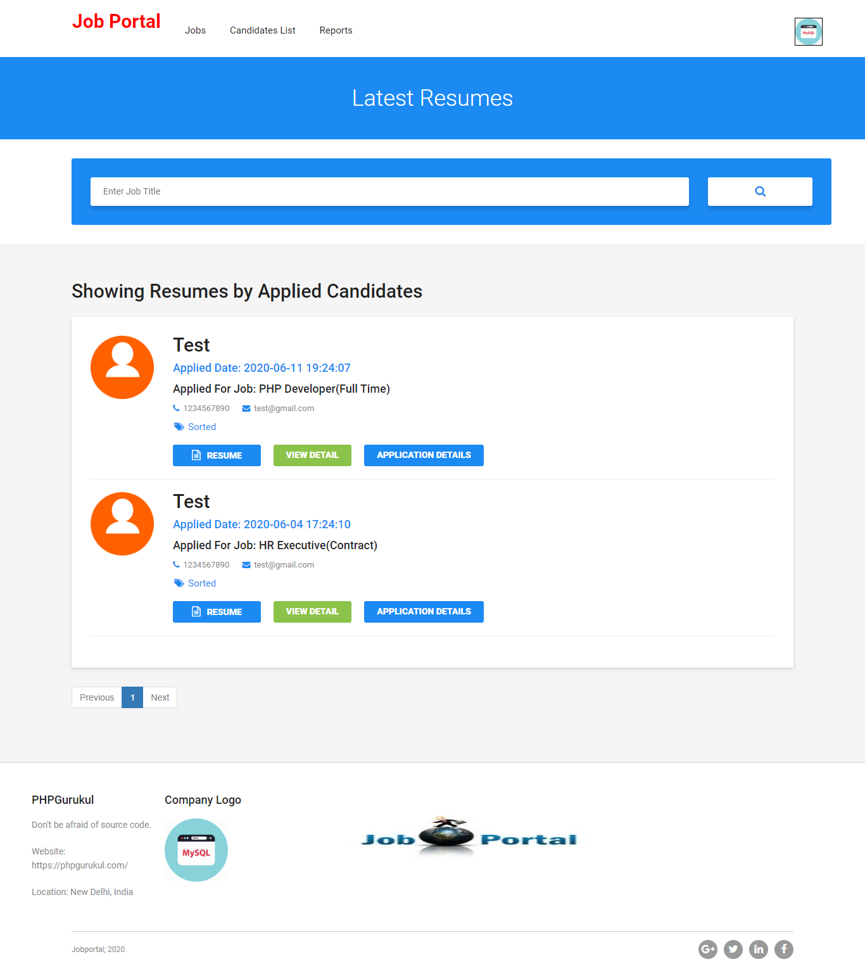

View Candidates Details

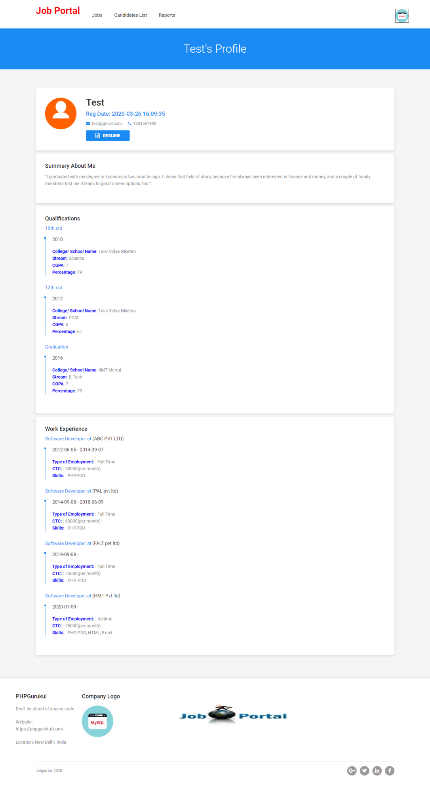

View Application Details

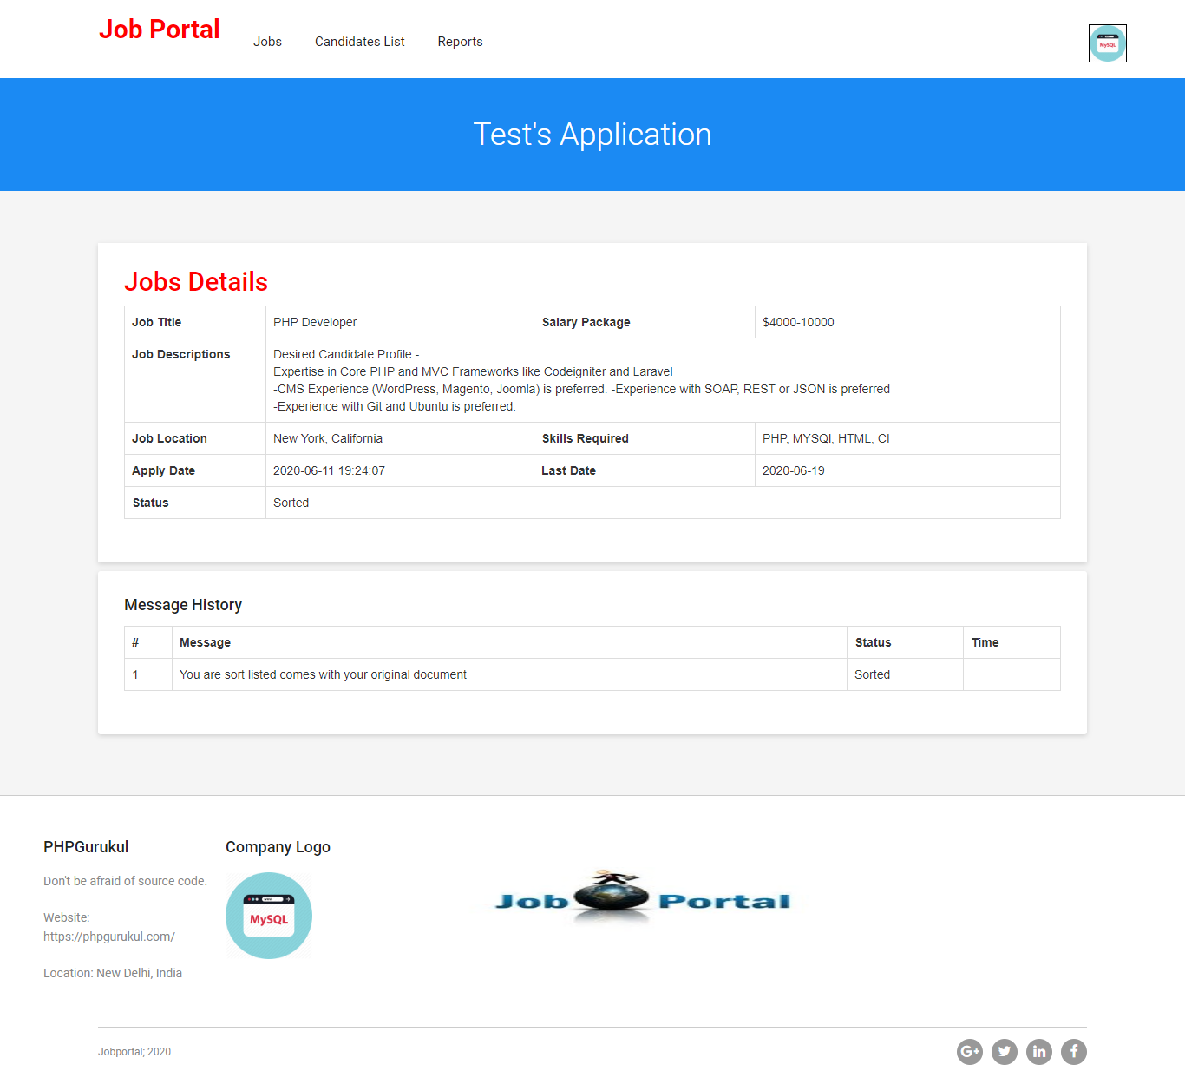

Between Dates Reports of Candidates

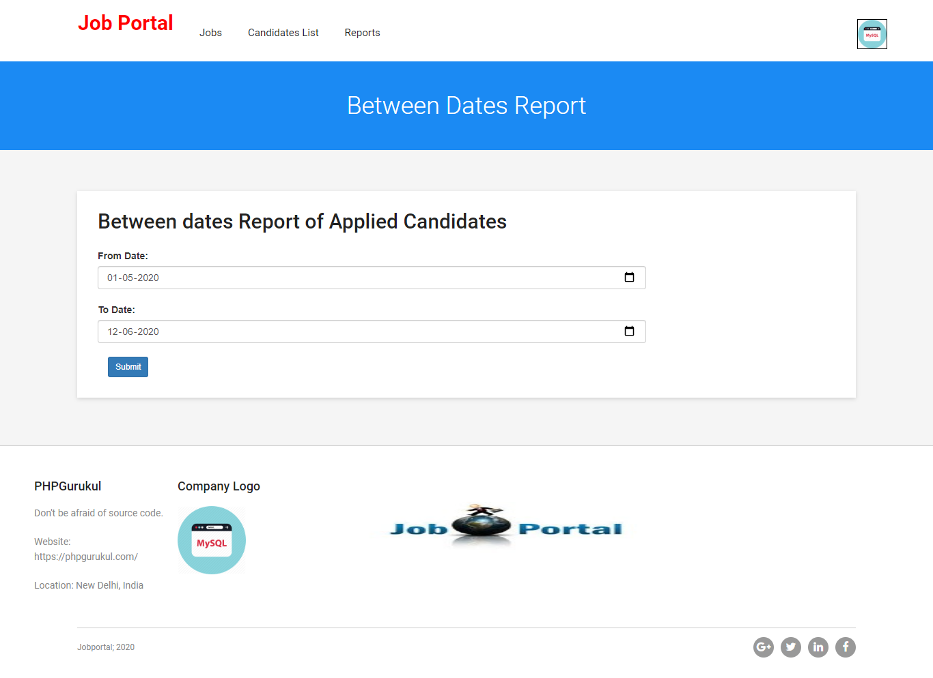

View between Dates Reports of Candidates

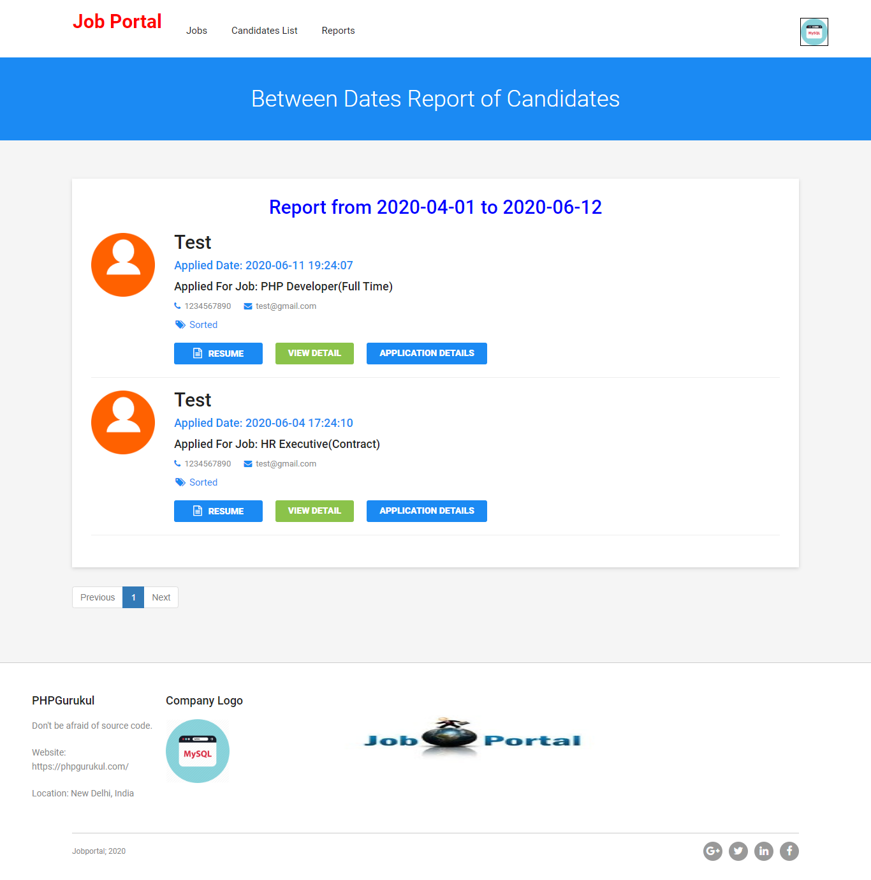

**CONCLUSION:**

The Application was designed in such a way that future changes can be done easily. The following conclusions can be deduced from the development of the project.

* Automation of the entire system improves the productivity.
* It provides a friendly graphical user interface which proves to be better when compared to the existing system.
* It gives appropriate access to the authorized users depending on their permissions.
* It effectively overcomes the delay in communications.
* Updating of information becomes so easier.
* System security, data security and reliability are the striking features.
* The System has adequate scope for modification in future if it is necessary.

**References**

**For PHP**

* <https://www.w3schools.com/php/default.asp>
* <https://www.sitepoint.com/php/>
* <https://www.php.net/>

**For MySQL**

* <https://www.mysql.com/>
* [http://www.mysqltutorial.org](http://www.mysqltutorial.org/)

**For XAMPP**

* <https://www.apachefriends.org/download.html>